Clifford Jones
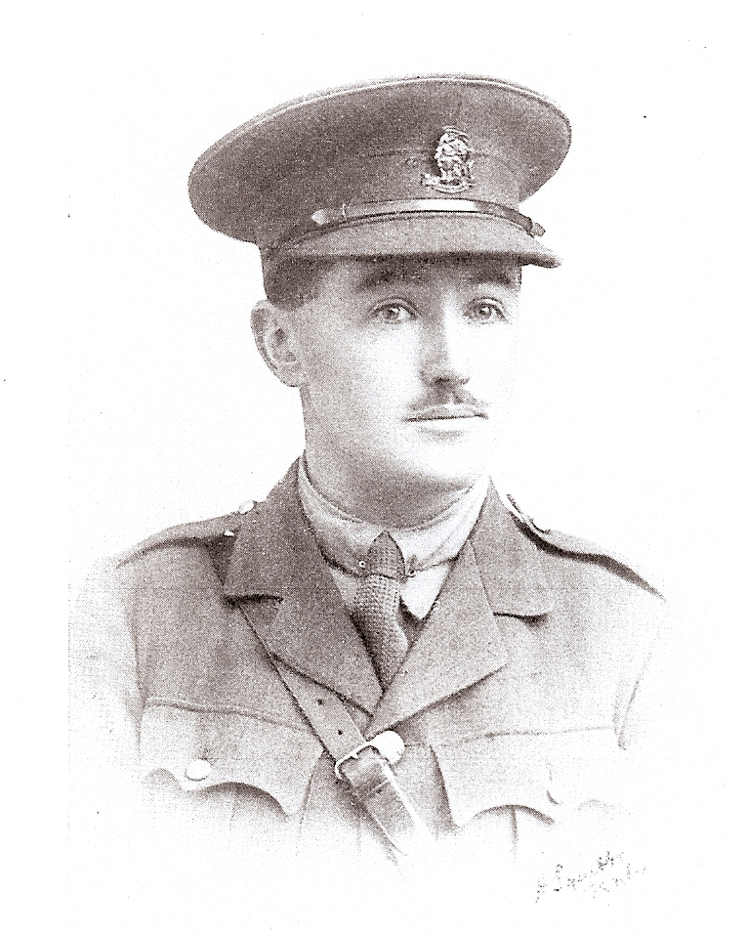

Clifford Jones, born on 8 February 1892, was the only son of the late Rev Daniel Jones and Mrs E A Jones of Whitland, Carmarthenshire. He was educated at the County School, Whitland, where he passed the Junior and Senior Certificate Examinations of the Central Welsh Board. He also obtained his ‘Honours Senior’, and subsequently won an Entrance Scholarship to Aberystwyth. During the next two years he completed his BA course and in the third year took Honours in English. In October 1912, he entered Jesus College, Oxford and after two years there took his BA with English Honours.
He joined the staff at Bushey in September 1915. He was anxious to join up and only consideration for his widowed mother, who was dependent on him, prevented him from enlisting earlier. In January 1916 he joined the Artists’ Rifles, obtaining a commission with the Royal Welsh Fusiliers at the end of that year, and proceeded to Belgium, where he served near Ypres right up to August 1917. He took part in the great attack on July 1917 and was killed in action on 2 August of that year. He was buried on the battlefield near Ypres but his body was afterwards removed to Dragoon Camp Cemetery.
His CO, Major Edwards, wrote: ’His handling of his men in the last attack was so heroic that, had he lived, he would have been recommended for distinction. In the attack on Passchendaele all the officers in the Brigade had been killed with the exception of Captain Latto and Lieutenant Jones. Their handling of the men, who were marched up to consolidate the position, won the admiration of their superiors’.
During the short time that he was at the School he was universally liked by his colleagues and the boys for his unassuming character and his devotion to duty.
Memorials of Masonians who fell in The Great War
Clifford Jones’ father was a Baptist Minister and his home address was ‘Bodlondeb’, Whitland, Carmarthenshire.
Clifford Jones died at the age of 25. There is no record of his burial at Dragoon Camp Cemetery. He is remembered with honour on the Menin Gate, panel 22.
He is commemorated on the Bushey Memorial.

