Gustav Adolph Kaye (Koenigsfeld)

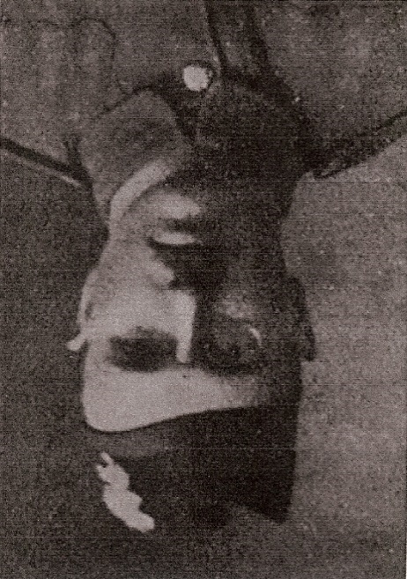
Gustav Adolph Kaye (Koenigsfeld), born on 8 May 1883, was the only son of Prussian parents, Gustav Emil Koenigsfeld (1839 -1911) and Helene Koenigsfeld (1850 - 1912). His father established himself in England as a merchant and commission agent and in 1877 he married Helene Dietrich and they both gained certificates of naturalisation. They lived at 65 Angell Road, Brixton, then in Surrey. Their two children, Gustav and Alice, were born in Brixton and Gustav was educated at Dulwich College. By the time of the 1911 census the Koenigsfeld family was living at 143 Tulse Hill, a twelve-roomed house, where they employed two servants. Gustav was then working as a commercial clerk.
In the spring of 1911, Gustav’s sister, Alice, married George Vasmer, a cocoa merchant of German origin, whose family owned ‘Caldecote’ in Hilfield Lane, Bushey Heath, Hertfordshire. George and Alice made their first home nearby at ‘Heimat’, Coldharbour Lane, Bushey, the German word for homeland. Gustav Emil Koenigsfeld died in December 1911 and his wife the following year. Gustav moved to 24 St James Court, Buckingham Gate and carried on business as a merchant at 60 Queen Victoria Street in the City of London.
On 2 October 1914, Gustav, like many residents of German origin, changed his name by deed poll and a public announcement was made in The London Gazette of 6 October 1914 that henceforth he would ‘utterly renounce, relinquish and abandon the surname Koenigsfeld’ and would be known as Gustav Adolph Kaye.
Soon after the war began, he enlisted as Private Kaye 293066 in the 3/4th Territorial Reserve Battalion, The Black Watch at Ripon. He was promoted to Lance Corporal and proceeded to France in June 1916. In December he was taken ill with enteric fever and double pneumonia and sent to the Base Hospital, Boulogne, where he lay dangerously ill until invalided home in June 1917. During convalescence he was in hospital at Norwich and later at Hunstanton. On recovery he joined the 7th Battalion of his regiment in Ireland and returned to the front in September 1917. He died of wounds received at Bourlon Wood near Cambrai on 23 March 1918, aged 34. He was buried in Moeuvres Communal Cemetery Extension, grave number Vi. C. 21.
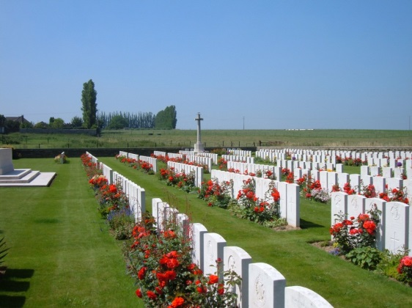
Through family inheritance, Gustav Kaye became a wealthy man and left an estate valued at £32,664 18s 3d, probate being granted to George Henry Stockman, managing director, and Julius Cecil Day, accountant. In his will he left money to charity aimed at relieving the distress after war amongst married women belonging to the Black Watch. Any surplus was to go to the Black Watch memorial Home at Dunalastair, Broughty Ferry. The charity ceased in 1996.
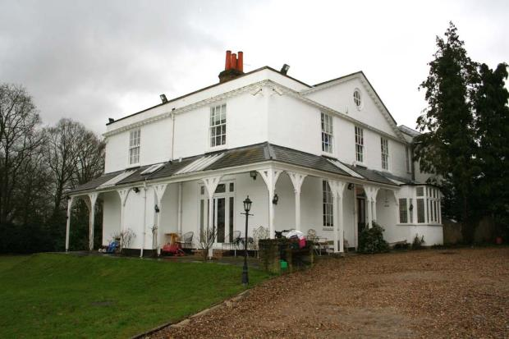
‘Caldecote’, Bushey Heath
Alice and George Vasmer, whose permanent home became ‘Caldecote’, Bushey Heath, had Gustav’s name inscribed on the Bushey Memorial.
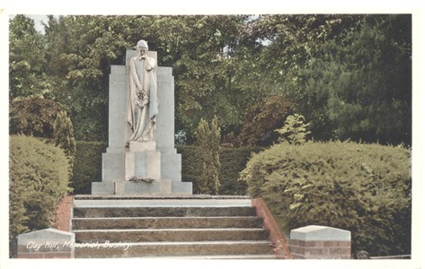
Bushey Memorial
He is also commemorated on his parents’ grave in West Norwood Cemetery, near the family home where he and Alice grew up.
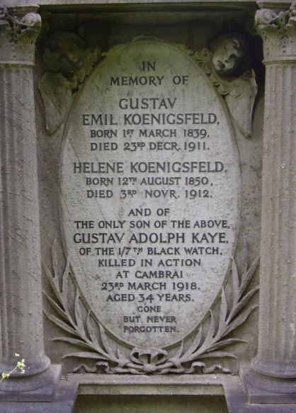
Sources:
CWGC
Ancestry.com
Dulwich College War records 1914-19
The London Gazette

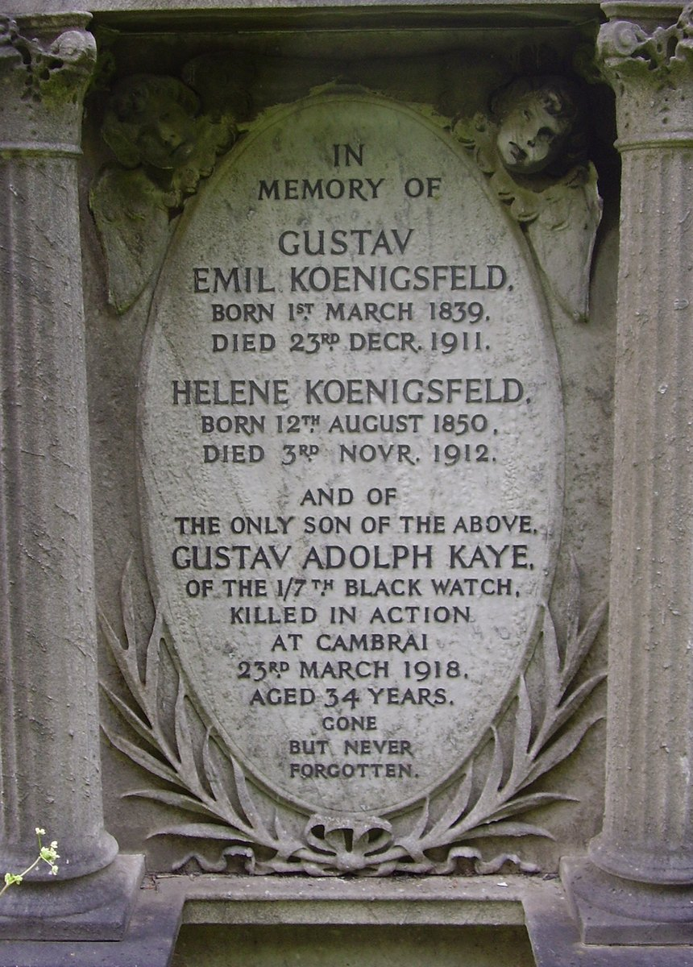

Bottom of Form
Name: | Gustav Emil Koenigsfeld
Age in 1911: | 72
Estimated birth year: | abt 1839
Relation to Head: | Head
Gender: | Male
Birth Place: | Germany
Civil Parish: | Lambeth
County/Island: | London
Country: | England
Street address: | 143 Tulse Hill S W
Marital Status: | Married
Occupation: | COMMISSION AGENT
Registration district: | Lambeth
Registration District Number: | 25
Sub-registration district: | Norwood
ED, institution, or vessel: | 10
Piece: | 2109
Household Members: | Name Age  Gustav Emil Koenigsfeld 72  Helen Koenigsfeld 60  Gustav Koenigsfeld 27  Alice Koenigsfeld 26  Emma Sharman 50  Kate Newton 37

George C Vasmer
Registration Year: |  |  |  | 1911
Registration Quarter: |  |  |  | Apr-May-Jun
Registration district: |  |  |  | Camberwell
Parishes for this Registration District: |  |  |  | View Ecclesiastical Parishes associated with this Registration District
Inferred County: |  |  |  | London
Volume: |  |  |  | 1d
Page: |  |  |  | 1591
Records on Page: |  |  |  | Name  Francis R Chalklin  Alice H C E Koenigsfeld  Caroline Manning  George C Vasmer

