David Keith-Johnston
Robert and Jessy Keith-Johnston lived at ‘Sparrows Herne Lodge’, a sizeable house later re-named ‘Upton Lodge’, which stood just above Bushey Library, where Upton Lodge Close is today.
Flight Lieutenant David Keith-Johnston of the Royal Naval Air Service was killed at Ostende on 10 August 1915, in action against German aircraft. He was initially logged as ‘missing’. He was a pupil at Felsted School in Essex. Mounted on the wall in the School Chapel is part of his tombstone made by the Germans who found him.
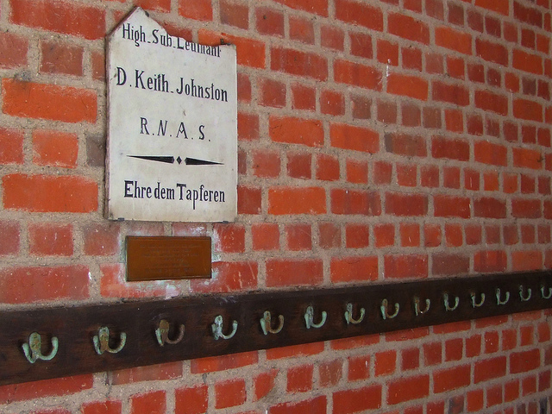
He is remembered with honour at Ramscappelle Road Military Cemetery in Belgium. He and his brother are commemorated on the Bushey Memorial and at St Peter’s Church, Bushey Heath

At St Peter’s Church, two groups of three windows were given by
members of the congregation in memory of their loved ones who
died in the Great War.

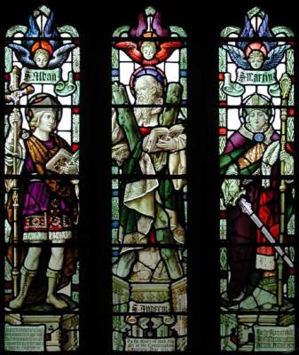
St Alban, St Andrew & St Martin

St Alban - in memory of David & Macfie Keith Johnston in 1915
St Andrew - given by the congregation on Armistice Day 1923
St Martin - given by the congregation on the Patronal Festival 1924

