Reginald St George Lake
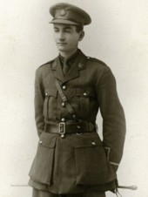
Reginald St George Lake, born on 4 December 1887, was the son of Reginald John and Mary Beatrice Lake and grandson of George Lake of Bushey House in Bushey High Street. He was one of eight children and lived in the family home ‘Beodiceworth’, Alexandra Road, Watford. His father was a barrister. At the time of the 1911 census Reginald was 23 and a banker. He gained as commission and served as a Lieutenant with the Oxford and Bucks Light Infantry. He served on the Western Front and died on 17 November 1916, aged 28. He is remembered with honour at Martinpuich British Cemetery in France. His name and that of his brother John Stephen Raymond Lake, who was killed in action in June 1916, are on the side of their grandfather’s grave in Bushey churchyard.
