Leonard Le Rossignol

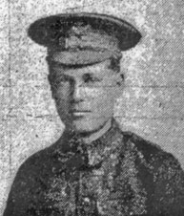

Leonard Le Rossignol (meaning nightingale) was the son of Francis Le Rossignol from the Channel Islands and his wife Pauline, who lived in Holloway, where Leonard was born, and later at 'Argyle House', The Avenue, Surbiton Hill, Surrey. His father, an architect and surveyor, died in 1900 in London, when Leonard was about 13 and his sister, Pauline, was 11.
Leonard became an insurance clerk and during the war served with the London Regiment as Rifleman 3021. He was killed on 1 July 1916, the first day of the Somme, aged 29, and is commemorated on the Thiepval Memorial to the Missing.
His mother moved to Pendower, Oxhey Drive, Northwood after his death to be near her married daughter.
