John Harvey Leckie
John Harvey Leckie, the son of Charles Stuart and Mary Alexandria Leckie, was born in Siam (now Thailand) in about 1890. In 1901 Charles Leckie, a widower, was living at Little Cassiobury in Watford with his sister and four servants. He was a Siam Merchant, the London Manager of the Bornes Company’s Siamese business. John, who was eleven, was a boarder at Park House School, Reading in Berkshire. Charles Leckie died in 1905 and at the time of the census in 1911, John was living with his unmarried aunt and two servants at The Grange, Waltham St Lawrence, Twyford, Berks. He was single and a University Army Cadet.
When war broke out he enlisted with the 1st Royal Dragoons and served on the Western Front as a Lieutenant. The Royal Dragoon Guard War Diary (WO 95/1153) records the circumstances of his death.
13/5/15 4 am - Very heavy bombardment of GHQ line [near Ypres in the Second Battle of Ypres], Railway, Shell-out Camp to HALTE commences. Our wood was heavily shelled and the ground all around but no damage was done. The fire trenches in front did not get a very heavy fire. The enemy employed Heavy Howitzers, HE shrapnel and 'whizz-bangs'.
Lieutenant Leckie was killed near the front edge of the wood; 2/Lt Bagshawe was killed after being slightly wounded on his way back to the trenches. These two officers were afterwards buried where they lay by the Irish Fusiliers.
Lieutenant John Harvey Leckie was 25 and is remembered with honour at the Menin Gate Memorial, panel 5. He is commemorated on the memorial at Waltham St Lawrence, Berkshire, where he lived.
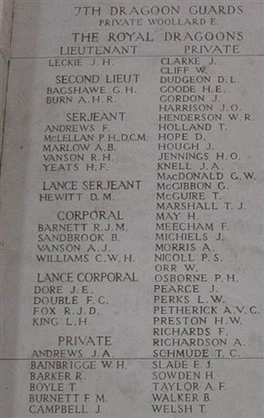
His father was buried in Bushey churchyard in 1905 and John’s name was later added to the memorial cross. (A3)

