**John Stanley Leeds**



John Stanley Leeds was the elder son of John Henry Sandford Leeds, from New York, and Beatrice Maud Goddard. His parents married in Little Stanmore, Middlesex in 1886 and John was born in Hadley Wood, near Barnet, the following year. On 22 February 1892, his father died in California, leaving his mother with four very young children. She was fortunate to have private means and the family settled at ‘Pasadena’, Caldecote Hill, Bushey Heath, where they employed a cook and a parlour maid. John attended Stanmore Park Preparatory School, where the headmaster was Rev Vernon Royle, the former Lancashire and England cricketer. In September 1901 he went as a boarder to Sherborne School, where he remained until August 1905. In his final year he became a member of the shooting team. He then attended King’s College, London and became an engineer. By the time of the 1911 census, John, now 23, was a qualified electrical engineer employed by a telephone company, living at home with his mother, two sisters and younger brother. His career as a mining engineer took him to Argentina but in September 1914 he returned to join the Honourable Artillery Company and gained a commission. As Second Lieutenant he went to Flanders in June 1915. He was killed in the crater at Hooge on Sunday 19 September 1915, aged 28, and was buried at Brandhoek Military Cemetery in Belgium, grave I. D.2. He is commemorated on the Bushey Memorial on Clay Hill and at St Peter’ Church, Bushey Heath. Sources: Ancestry.com & Sherborne School Archive

[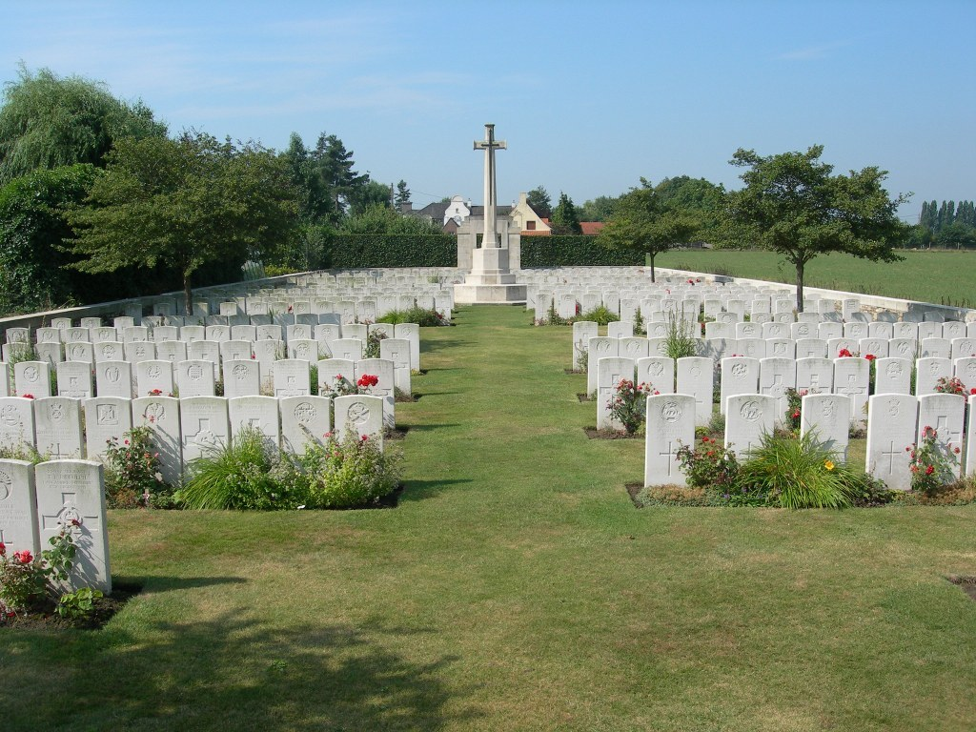](http://www.cwgc.org/dbImage.ashx?id=121)