James Wickham Ley
James Wickham Ley, born in Hampstead, Middlesex, on 10 July 1877, was the son of James Verchild Lay and Mary Jewell Wickham of 171 Adelaide Road, Hampstead. His father was a stockbroker and James was the third of their five children. The family employed four servants and at the time of the 1891 census James was at boarder at Weybridge School in Surrey. His youngest sister, Rosamund, became a concert pianist.
James had a military career with the North Staffordshire Regiment. At the time of the 1911 census, he was married to Helen Strode Sinclair and, holding the rank of Captain, was serving in India. When war was declared he continued to serve in India and then in Mesopotamia from 1916. He rose to the rank of Major and was awarded the DSO. He died in Mesopotamia on 22 October 1918, aged 41. He is remembered with honour at the Tehran War Cemetery.
His sister, Margaret Ley, who was a miniaturist, was married to William Sewell of the Herkomer Art School and lived in Bushey Heath. In 1923, James’ mother, Mary Jewell Ley, was living at ‘The White House’, Bushey Heath.
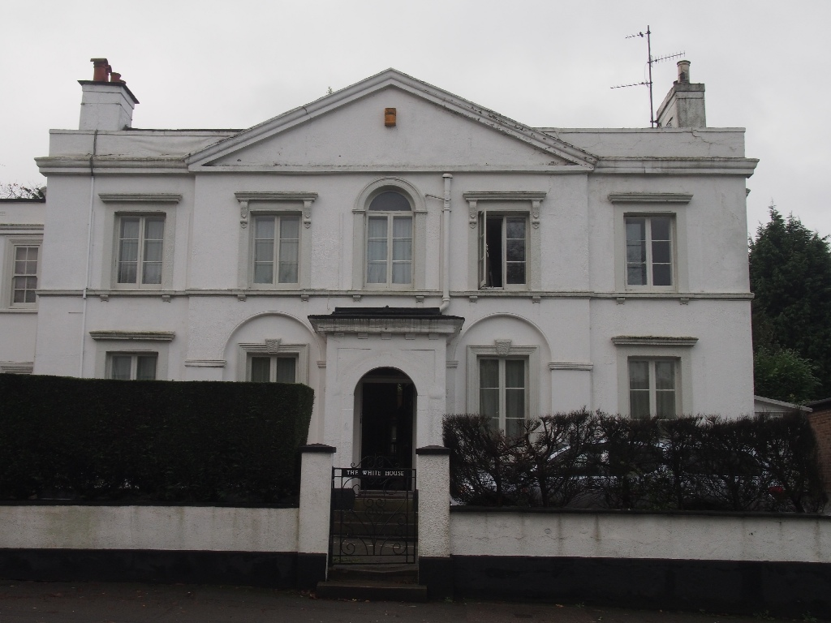
The White House, Bushey Heath.
Photograph: Patrick Forsyth, Bushey Museum

She gave a reading desk and chair to St Peter’s Church, Bushey Heath, in memory of her son and her son-in-law, William Sewell, who was killed in action in France on 23 April 1917.
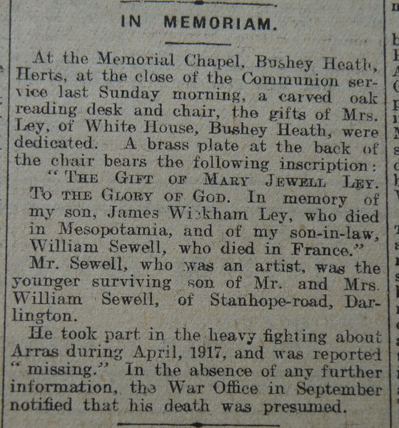
Darlington & Stockton Times 31 March 1923

