John William Oliver Marshall
John William Oliver Marshall was born in Blakesley, Northampton in 1886. He was the son of Ebenezer Marshall, an agricultural labourer, and his wife, Elizabeth. John was a stockman and married Mabel Julia York in September 1908. They had two children. He enlisted in 1916, aged 29, in Watford as Private 35329 in the Middlesex Regiment. He was resident in Bushey at 23 Primrose Gardens, School Lane. He transferred to the Labour Corps and died at home on 24 August 1917. He was buried in Moulton Cemetery in Northampton and he is commemorated on the Bushey Memorial and at St Peter’s Church, Bushey Heath.

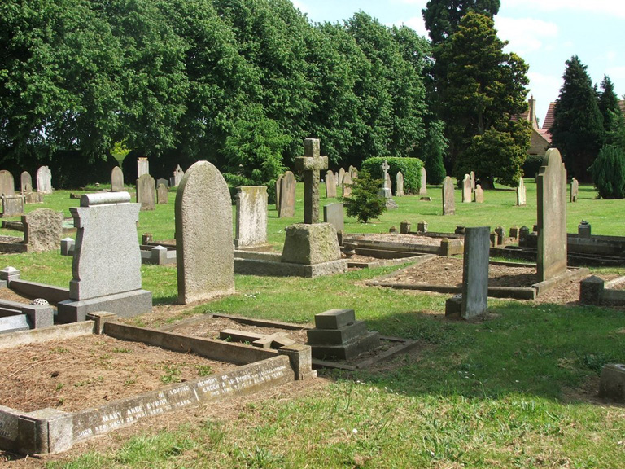
Moulton Cemetery in Northampton

