Harry Cecil Osborn
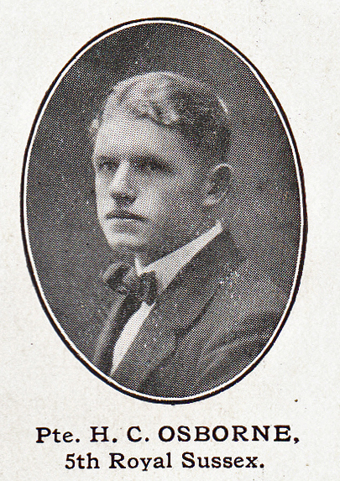
Source: The Fullerian WBGS
Harry Cecil Osborn, born on 9 November 1895, was the second son of Charles and Elizabeth Osborn of ‘Branksome’, 4, Kingsfield Road, Oxhey, who had six children. His father was a corporate accountant and Harry attended Watford Boys’ Grammar School from 1904 until 1911.
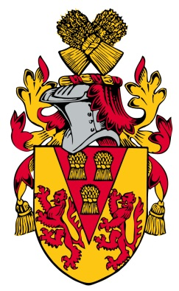
He joined the Royal Sussex Regiment as Private G/18143 and died on 9 April 1918, aged 23. He is commemorated at the Senlis Communal Cemetery on the Somme. His name does not appear on any of the Bushey or Oxhey war memorials as his father moved
to Westcliffe-on-Sea.
(He is recorded as H C Osborne on the Watford Grammar School records)
