James Alan Pearson
James Alan Pearson was born on 9 March 1899 in Chesterfield, one of two children and the only son of James and Harriet H Pearson. His father was an earthenware manufacturer. In 1901, when James was two years old, the family lived at The Manor House in Chesterfield, where they employed four servants. His father died in 1905 and about two years later his mother married James Anderson Goodfellow, a doctor, and the family lived at Grove House, Ashover, near Chesterfield. James, who was twelve in 1911, was a pupil at Edgbaston Preparatory School in Birmingham.
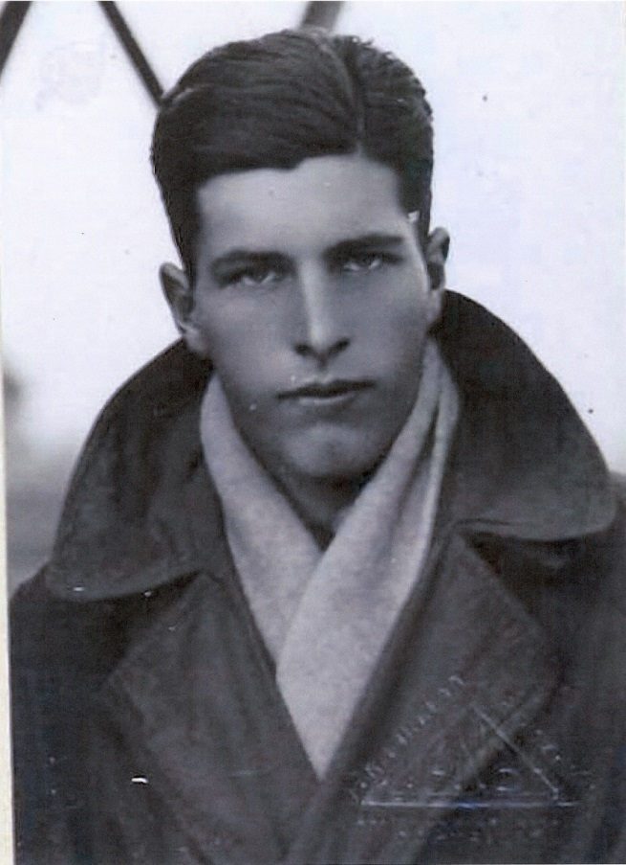
James trained with the Royal Flying Corps and qualified as a 2nd Lieutenant on a Caudron Biplane at Ruffy-Baumann School. His certificate, dated 11 September 1917, shows his address as ’Myoora’, Grange Road, Bushey. He was killed in action two months later, on 9 December 1917, aged 18, and was buried at St Mary’s Churchyard, Docking, Norfolk. His mother was later resident at The Hall, a hotel in Bushey, and her son’s name is on the Bushey Memorial.

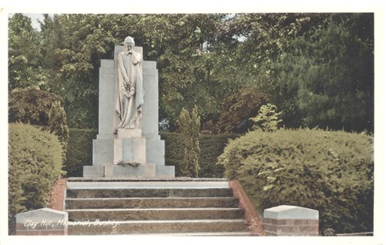

Bushey Memorial, Clay Hill
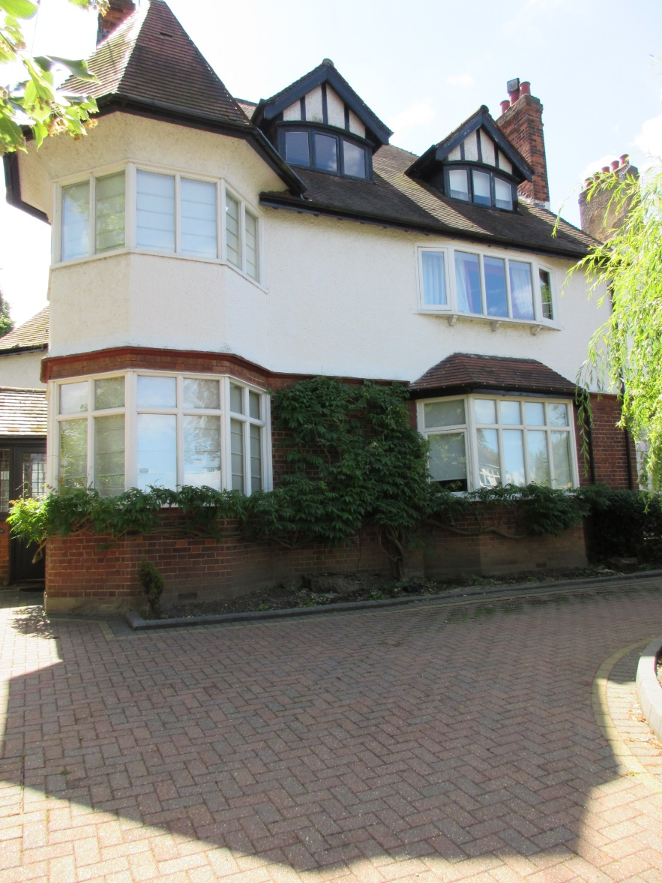
‘Myoora’, Grange Road, the last house before Manor Field
Home of Lieutenant James Alan Pearson

Additional information proved by Alwyn Jones 27/06/2015

2nd/Lt James Alan Pearson of 110 Squadron RFC was only 18 years old when on 9 December 1917 he lost consciousness (a phenomenon caused by the so-called G-force, subjecting pilots of military fighter jets and high performance aerobatic aircraft to forces of acceleration equivalent to many times the force of gravity) whilst pulling the Martynside (B866) aircraft he was flying out of a deep dive, and fell out of the open cockpit of his aircraft at 1500ft. His grave can be found along the north-western boundary of St Mary's churchyard in Docking.

TF7637 : Grave of 2/Lt James Alan Pearson

near to Docking, Norfolk, Great Britain

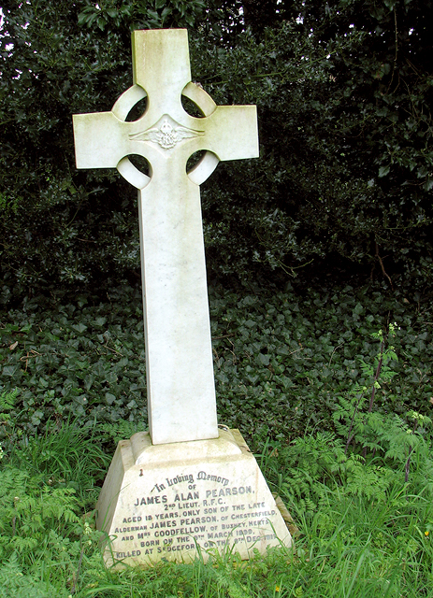
Grave of 2/Lt James Alan Pearson
2/Lt James Alan Pearson was a Royal Flying Corps pilot. He was killed at the Sedgeford aerodrome on 9 December 1917.
© Copyright Evelyn Simak

Source: RAF Sedgeford :: Geograph Britain and Ireland

