Bernard John Pullin
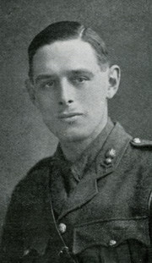
Bernard John Pullin, born on 27 March 1888, was the youngest son of James and Marion Pullin of 7 Amherst Park, Stanford Hill, London. He was educated at a private school in Cambridge with his older brother, Arthur, and at Mill Hill School, London NW7 from 1903 to 1912. He was a prominent swimmer at school and won the Ousey Bowl for swimming. He qualified as an analytic chemist.
On 13 November 1914, at the age of 26, he joined the Territorial Forces as Sapper 70044. He gained a commission as a Lieutenant in the Royal Field Artillery, 4th Home Counties Brigade and served in France. He was killed in action at Passchendaele, Belgium, on 21 October 1917, aged 29. ‘He was in command of his battery when they were ordered to move forward. He did a most difficult advance over roads that were quagmires and got all his guns into action. His junior officers all became casualties, but he carried out registration and barrage fire single-handed, working unceasingly day and night under constant shell fire, setting a magnificent example of courage and determination to his men.’
He was awarded a posthumous Military Cross for conspicuous gallantry and devotion to duty and was buried in Dozinghem Military Cemetery, Poperinge, West-Vlaanderen, Belgium. Plot IX Row C Grave 23.
His parents moved to ‘Myoora’, Grange Road, Bushey after the war. He name is not on any Bushey war memorial, but he is commemorated on the family grave in Bushey churchyard.
The children of Bernard’s brother, Arthur Pullin, grew up in Oxhey and went on to serve with distinction in WW2. (John) Anthony Pullin DSC served as a fighter pilot with the Fleet Air Arm before returning to live in Watford, and Joy Olive Pullin (later Salmon) worked as a WREN at Bletchley Park, operating Turing's Bombe machines.
Sources: Mill Hill School Roll of Honour and Ben Jewitt, a member of the Pullin family.

