Alexander James Purssell
Alexander James Purssell, born in Watford in 1894, was the youngest son of Emma Purssell, who was widowed in about 1897 and left to bring up four children. The family lived at 16 Capel Road, Oxhey and Emma worked at home as a laundress, helped in later years by her eldest daughter. In 1911, when Alexander was sixteen, he was working as a store boy at the gas works.
He enlisted in London as Private 2995 with the London Regiment, 1st battalion and was killed at Gallipoli on 27 September 1915, aged 20. He was buried at Green Hill Cemetery, Gallipoli and is commemorated on the memorial at St Matthew’s Church, Oxhey.
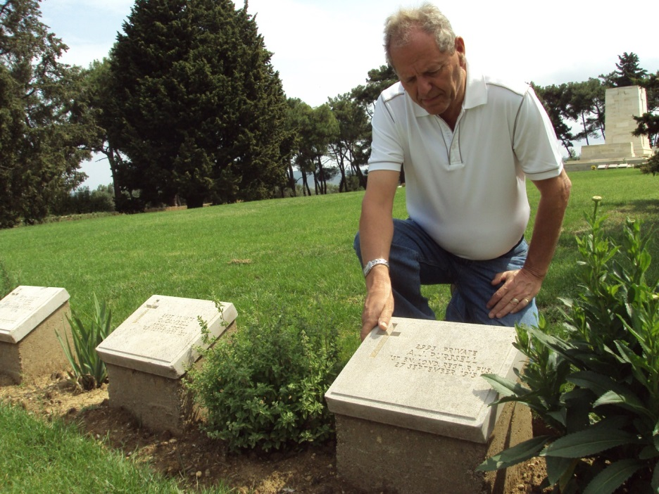
Alwyn Jones (member of Exhibition team) in Gallipoli
at the memorial of Alexander Purssell (2014)

