Frederick Ernest Riggs
Frederick Ernest Riggs, born in London in 1888, was one of seven children born to Joseph Riggs and Elizabeth Lee. In 1891 the family were living at 20 Springfield, Bushey Heath and his father was a Metropolitan Police Constable. Six years later, his father died at the age of 38 and his mother worked as a charwoman. In 1901, while other family members remained at home, Frederick, aged 13, was at school in the Metropolitan Police Orphanage in Twickenham.
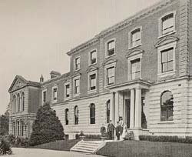

Metropolitan Police Orphanage, Twickenham

Elizabeth and her family moved to 86 School Lane and later to 31 Sparrows Herne. In 1904 Frederick enlisted as a soldier but the 1911 census shows him as an inmate of H M Prison, Kingston. When war broke out he served as Private 11299 in the Worcestershire Regiment, 2nd Battalion and was awarded the Distinguished Conduct Medal for bravery. He died of wounds on 27 September 1915, aged 27. He was buried at Vermelles British Cemetery in France and is commemorated on the Bushey Memorial and at St Peter’s Church, Bushey Heath.

