Walter Rolph

Walter Rolph, born in 1887, was fourth son of George and Mary Ann Rolph of 7 Sotheron Road, Watford. His father was a sawyer and George and Mary Ann had ten children, including twins. Mary Ann died in 1893 at the age of 39 and two years later George married Elizabeth Chapman, with whom he had two more children. By the time of the 1911 census, Walter was living with some of his siblings and his step-mother, who was now a widow. He was 24 and was employed as an auxiliary postman. The following year he married Emily Dilks in Watford. Emily was the eldest daughter of William and Sarah Dilks, an established Bushey family, who lived at 116 Pinner Road, Oxhey in 1911. Emily was employed as a Christmas card finisher printer.

By the time Walter enlisted, he and Emily were living in Ebury Road, Watford. He joined the 6th battalion of the Duke of Cornwall’s Light Infantry as Private 27801 and served in France and Flanders. He was killed in action on 16 September 1916 at the Somme and is remembered with honour on the Thiepval Memorial to the Missing, pier and face 6B. He is commemorated on the memorial at St Matthew’s Church, Oxhey, where he is listed as W Ralph.

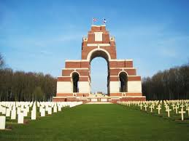

Emily’s brother, William Dilks, a Private in the Bedfordshire Regiment, served in France and Flanders and was killed in action on 1 March 1918. He is also commemorated at St Matthew’s, Oxhey.

