Harold Cecil Round

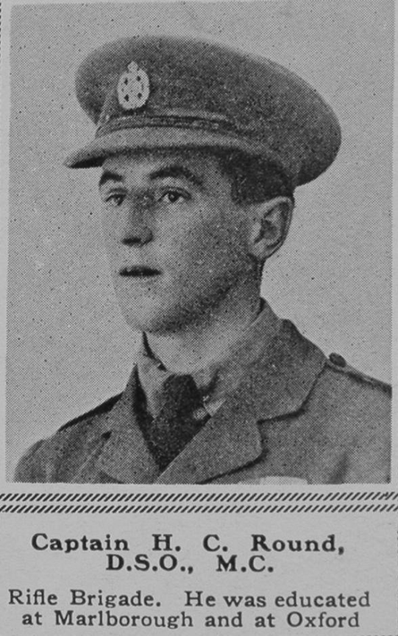

Harold Cecil Round, born in 1897, was the youngest son of the Francis Richard Round and his wife Frances Emily Round. His father, a high-ranking civil servant in the Colonial Office, received the CMG, the Order of St Michael and St George, awarded to men and women who rendered extraordinary or important non-military service in a foreign country. He and his wife had seven children and in 1901 the family home was Sutton Court, Sutton, Surrey, where he employed a governess and four servants. By 1911, he had retired, was a JP for Essex and the family had moved to ‘Avenue House’, Newland Street, Witham, Essex. In 1911, Harold was 14 and a pupil at Marlborough College in Wiltshire.
When war broke out he gained a commission with the Rifle Brigade and served as a Second Lieutenant. He was awarded the Military Cross for exemplary gallantry and, after a later engagement, when he held out with his men and got back safely, he was awarded a DSO for conspicuous gallantry and devotion to duty. The citation states: ‘When our troops were forced to withdraw he collected a few men and made a strong-point within 70 yards of the enemy trench. This position he held for two days without supplies of any kind. He was finally able to get a valuable report through before being ordered to withdraw.’ As a Captain, Harold Cecil Round MC DSO was later killed in action on 24 Aug 1917, aged 21. He is remembered with honour at Tyne Cot Memorial.
He and his brothers, Auriol Francis Hay Round and James Murray Round, are all commemorated on the memorial at St Matthew’s Church, Oxhey. The reason for this is that Emma Margaret Round, who married John Wilfred Lewis, by 1915 the vicar of St Matthew’s Church, Oxhey, was their cousin. Her sister, Lucy Frances Round, married Major Charles Ernest Higginbotham, who is also commemorated at St Matthew’s.
