James Murray Round
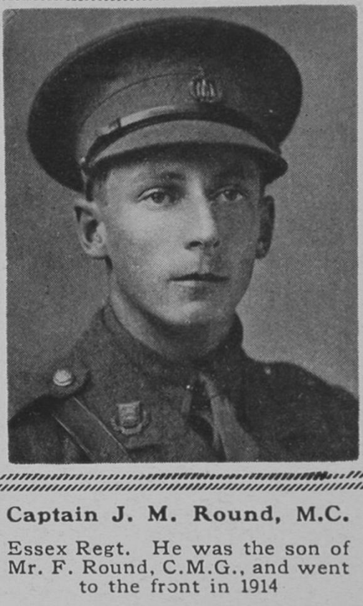
James Murray Round, born in born 21 February 1894, was the son of the Francis Richard Round and his wife Frances Emily Round. His father, a high-ranking civil servant in the Colonial Office, received the CMG, the Order of St Michael and St George, awarded to men and women who rendered extraordinary or important non-military service in a foreign country. He and his wife had seven children and in 1901 the family home was Sutton Court, Sutton, Surrey, where he employed a governess and four servants. By 1911, he had retired, was a JP for Essex and the family had moved to ‘Avenue House’, Newland Street, Witham, Essex. From 1907 until 1911, James was a pupil at Haileybury College, Hertford.
He joined the Essex Regiment and served as a Captain. He was award the Military Cross for gallantry. He died on 13 November 1916, aged 22. He was buried at the Serre Road Cemetery No. 2 on the Somme.
He and his brothers, Auriol Francis Hay Round and Harold Cecil Round, are all commemorated on the memorial at St Matthew’s Church, Oxhey. The reason for this is that Emma Margaret Round, who married John Wilfred Lewis, by 1915 the vicar of St Matthew’s Church, Oxhey, was their cousin. Her sister, Lucy Frances Round, married Major Charles Ernest Higginbotham, who is also commemorated at St Matthew’s.
