**David Alfred Rutherford**

David Alfred Rutherford, born in 1899 in Waltham Cross, Hertfordshire, was the second of three sons born to David Carter Rutherford and his wife Charlotte Ann. His father was an import and export merchant and in 1901, when David was two years old, the family lived at ‘The Hollies’ at Cheshunt in Hertfordshire, where they employed two servants. At the time of the 1911 census, they had moved to ‘Ivy Lodge’, Cheshunt, and David and his younger brother were pupils at Mostyn House School, Parkgate, in Cheshire.

On 10 May 1916, David Rutherford, as a Gentleman Cadet at the Royal Military Academy, gained a commission as a 2nd Lieutenant in the Royal Garrison Artillery. He served in France throughout the war and on 15 June 1917 was award the Military Cross for conspicuous gallantry and devotion to duty when acting as Forward Observing Officer.

‘He sent back most valuable reports on the situation, and eventually succeeded in establishing a telephone line in close proximity to the enemy’.

On 22 June 1918 a bar was added to the Military Cross, again for conspicuous gallantry and devotion to duty.

‘When in command of the forward section of the battery he kept all his guns in action under a heavy fire, until being ordered to withdraw late in the day he got his guns safely away across open country and over a railway embankment, the roads having become unpassable from shell fire. His quick and determined action saved the guns’.

On 15 October 1918 David was appointed Acting Captain but relinquished the rank on 8 April 1919.

The Irish War of Independence began on the 21 January 1919 and David Rutherford was deployed there with the Royal Garrison Artillery.

On 29 October 1920, Lieutenant Rutherford and Lieutenant Brown had 3 days’ leave. They departed from their base at Moore Park, Kilworth, Fermoy at 15.00. They were each riding a motorcycle, dressed in mufti and carrying officer’s haversacks and bedding. A sergeant on the base remarked "They don't look much like civilians"

They told the regiment that they intended to go to Killarney. They had 2 or 3 days of food, bedding and primus stoves with them in a sidecar. They were last seen filling with petrol at Kilworth village

Charlie Browne of Macroom IRA said that Brown and Rutherford were "dressed in civilian clothes, were armed" and that they were later executed as enemy spies.

Their bodies were never recovered

The British Army WO 141/94 does say ‘Brown and Rutherford had been employed from time to time on intelligence work...this may have been the reason for their murder’.

A Sergeant at the inquiry said, ‘Mr Brown was occupied in operations against Sinn Feiners on patrols, or with one man or by himself. He has told me of going out and pulling down Sinn Fein signs...I know of him being out more than once at night in the battery trap’.

Nothing except the short ‘missing’ announcement appeared in the press

It was not until 20 November 1921 that the British finally got proof from the IRA that Lieutenant David Rutherford and Lieutenant Brown had been executed.

The date of their death was given as 1 November 1920.

David Rutherford is remembered with honour at Hollybrook Memorial in Southampton, which commemorates by name almost 1,900 servicemen and women of the Commonwealth land and air forces, whose graves are not known, many of whom were lost in transports or other vessels torpedoed or mined in home waters.

[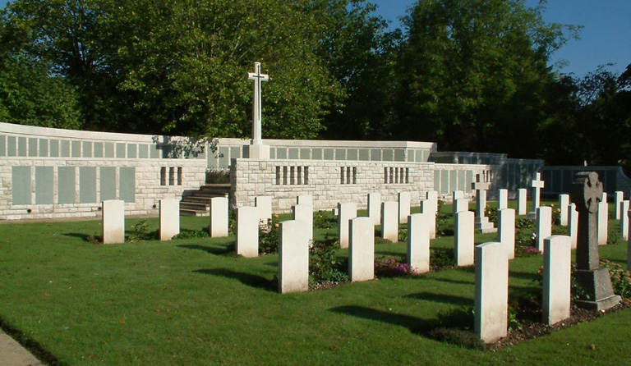](http://www.cwgc.org/dbImage.ashx?id=8741)

Mostyn House School, where David was a pupil, created as a war memorial a rare carillon of 37 bells on the roof over the entrance to the school chapel. The names of all former pupils who fell in the Great War are shown on a panel in the entrance to the chapel. David Rutherford’s name appears there. In 2012, the carillon and the commemorative panel were transferred to Charterhouse School.

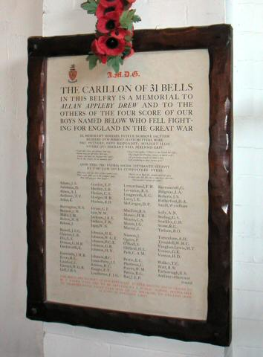

War Memorial, Mostyn House School, Parkgate, Cheshire.

|  |  |
| --- | --- |
|  |  |
| After the war, David and Charlotte Rutherford, now Lord and Lady Rutherford, came to live at ‘Powis Court’ in The Rutts, Bushey Heath. The tower at St Peter’s Church, built in 1913, had only a single bell so in 1921 Lord & Lady Rutherford gave a peal of eight bells in memory of their son.  *The inscription on the tenor bell confirms:-"To the glory of God and in loving memory of their dear son, Lieut David Alfred Rutherford, MC  RGA  killed in Ireland October 1920, these eight bells were presented by Mr & Mrs D C Rutherford, of this parish".*  st.-peter's  It was Sir David's custom to invite the ringers to his house for a meal on 3lst December before they went on to the church to ring out the Old Year and ring in the New.  For ringing out the Old Year the bells were muffled by strapping a leather pad on one side of the bell clapper so giving a dull and mournful sound at every other stroke.  At midnight the pads were removed and the bells rang out in their full strength.  Unhappily this practice had to cease because bells at midnight, even once a year, were not welcomed by the ever-increasing and largely secular local populace.  His parents continued to own ‘Powis Court’ until the 1930s. |  |