William Sewell

William Sewell, born in Darlington, Durham, in 1877, was the third son of William and Mary Sewell. His father was the managing editor of a newspaper in Darlington and also the town registrar. At the time of the 1891 census, William was fourteen and a boarder at Barnard Castle School in Durham.
In 1897 he became a student at the Herkomer Art School in Bushey in 1901 was lodging with William Holt, a police constable, his wife Miriam and their seven children at 7 Bournehall Road, Bushey.

By 1911 William had married Margaret Ley of St John’s Wood, a miniaturist, and they were living at ‘Carisbrook’, Little Bushey Lane. They had a daughter, Phillada, born on 20 May 1910 and employed a nurse and a domestic servant. They later moved to ‘Chester Cottage’, High Road, Bushey Heath.

William enlisted in Watford as Private 35962 in the Bedfordshire Regiment, 6th battalion. He served on the Western Front and was killed in action on 23 April 1917, aged 40. He is remembered with honour at the Arras Memorial and is commemorated on the Bushey Memorial and at St Peter’s Church, Bushey Heath. He is also commemorated on the War Memorial in Darlington, his childhood home. His daughter, Phillada, became a well-known actress. She died in 1998.

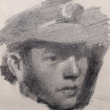 | 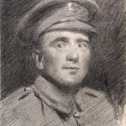
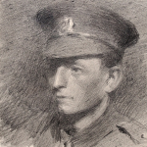 | 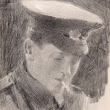
HEADS OF FOUR SOLDIERS
by William Sewell
Courtesy of Bushey Museum and Art Gallery

In 1923, Mary Jewell Ley, his wife’s mother, was living at ‘The White House’, Bushey on Sparrows Herne.
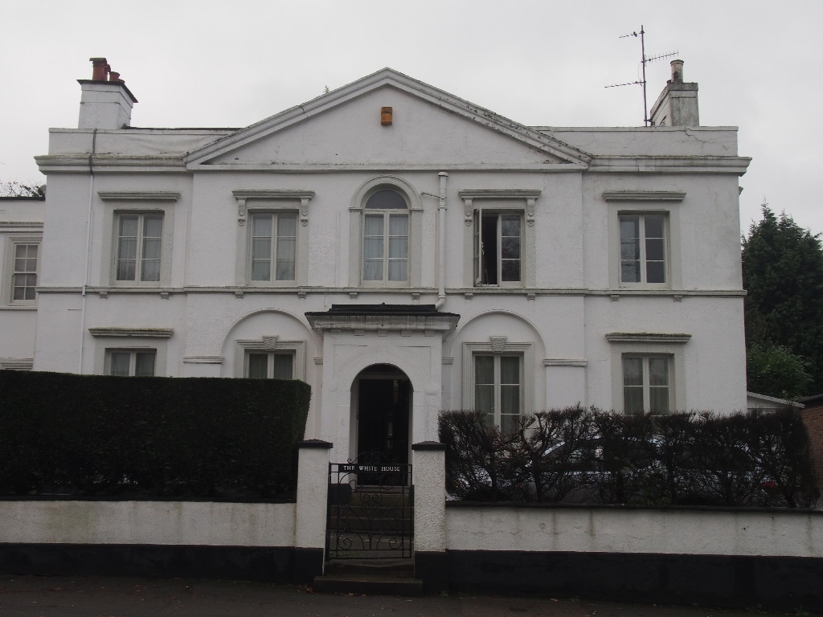
Photograph: Patrick Forsyth, Bushey Museum

An article in the Darlington & Stockton Times records her gift of a reading desk and chair to St Peter’s Church, Bushey Heath, given in memory of her son, Major James Wickham Ley, and her son-in-law, William Sewell.
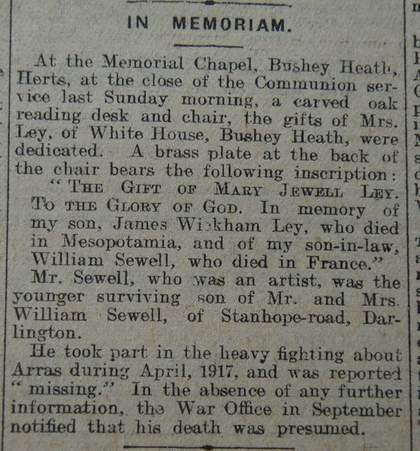
Darlington & Stockton Times 31 March 1923

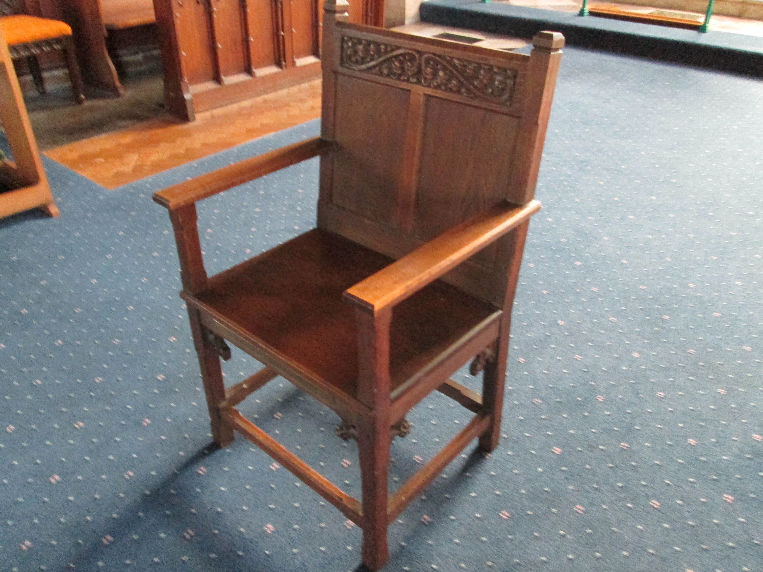

Chair donated to St Peter’s Church, Bushey Heath
in memory of James Wickham Ley and William Sewell

