Alec William Sims
Alec William Sims, born in Barnsbury, Islington, in 1898, was the son of Ernest George Sims and his wife Annie Elizabeth. He was one of four children. At the time he enlisted in Luton, he was 19 and gave his occupation as a poultry farmer at Badgers Hill, Stopsley, near Luton. His parents were living at The Croft, Great North Road, Highgate. Alec joined the Royal Medical Corps as Private113570 and served at home and died on 27 June 1917, aged 19. He was buried at Islington Cemetery and is commemorated on the village memorial in Stopsley. After the war his parents moved to Harts Farm in Bushey Heath.
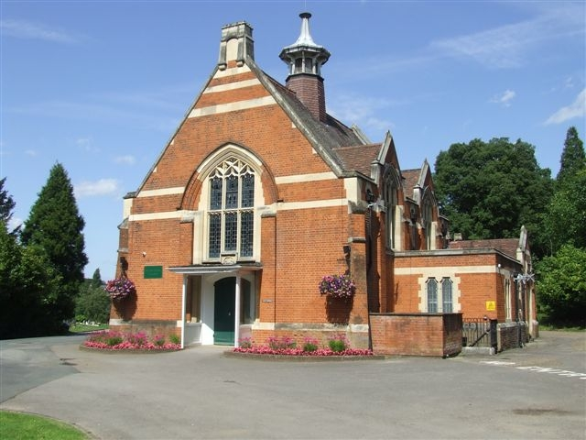
The Chapel at Islington Cemetery

