Albert Richard Smith
Albert Richard Smith, born in 1890 in Watford, was the fourth son of Job and Clara Smith of Watford. His father was a contractor’s labourer, who had 11 children, two of whom died in childhood. In 1911, the family was living at 26 Cardiff Road, Watford and Albert was employed as a bricklayer’s labourer. He enlisted in Watford with the Bedfordshire Regiment and served as Company Sergeant Major 17232 in France and Flanders. He was killed in action on 21 March 1917, aged 28. He is remembered with honour at Maroc British Cemetery, Grenay in northern France. His wife, Annie, later lived at 1 Capel Road, Oxhey and Albert is commemorated on the memorial at St Matthew’s Church, Oxhey.
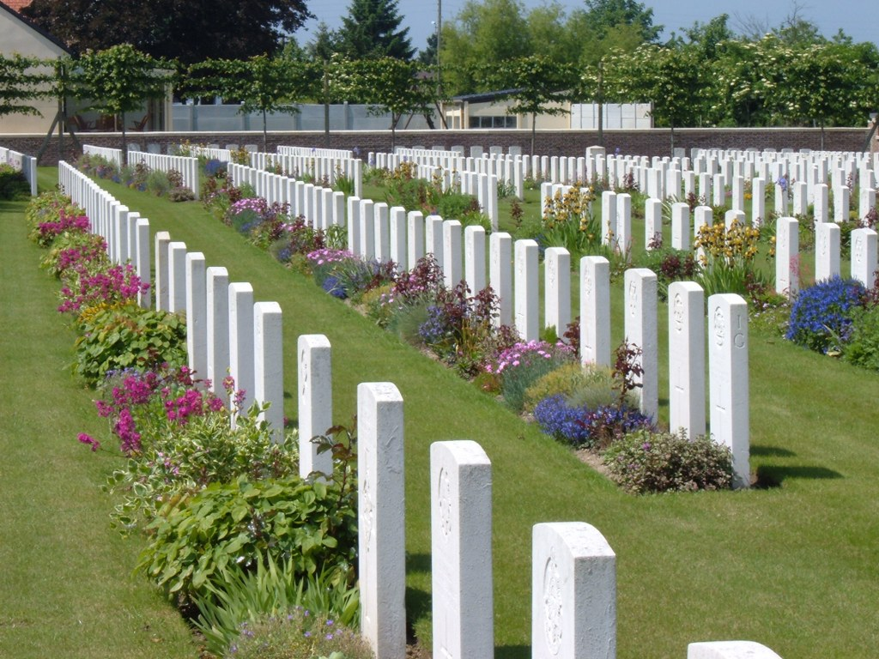

SMITH, ALBERT RICHARD 1, Capel Road, Oxhey, husband of Annie Comp Serg Maj 17232 Bedfordshire 28 21/03/1917 CWGC Maroc, Grenay SM 4th son of Mr & Mrs J SmithJob Smith  Age: 42  Estimated birth year: abt 1859  Relation to Head: Head  Gender: Male  Spouse: Clara E Smith  Birth Place: Bushey, Hertfordshire, England  Civil Parish: Watford  Ecclesiastical parish: Watford St Mary  County/Island: Hertfordshire  Country: England  Street address: Occupation: Condition as to marriage: Education: Employment status: View image  Registration district: Watford  Sub-registration district: Watford  ED, institution, or vessel: 19  Neighbors: View others on page  Piece: 1319  Folio: 7  Page Number: 5  Household schedule number: 29  Household Members: Name Age Job Smith 42 Clara E Smith 42 William J Smith 22 Arthur G Smith 20 Clara E Smith 16 Annie E Smith 15 Rose Smith 13 Albert R Smith 11 Eliza Smith 9 Charles E Smith 4 Harry Smith 38 | View  Original  Record  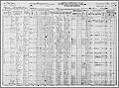  View original image

Richard Smith
Age in 1911: | 21
Estimated birth year: | abt 1890
Relation to Head: | Son
Gender: | Male
Birth Place: | Watford, Hertfordshire, England
Civil Parish: | Watford
County/Island: | Hertfordshire
Country: | England
Street address: | 26 Cardiff Rd, Watford, Herts
Marital Status: | Single
Occupation: | Labourer of Bricklayer
Registration district: | Watford
Registration District Number: | 140
Sub-registration district: | Watford
ED, institution, or vessel: | 19
Household schedule number: | 63
Piece: | 7717
Household Members: | Name Age  Job Smith 52  Clara E Smith 52  Clara E Smith 26  Elizabeth Smith 25  Richard Smith 21  Eliza Smith 19  Charles E Smith 14

Albert Richard Smith
Birth Place: | Watford, Herts
Residence: | Watford
Death Date: | 21 Mar 1917
Death Location: | France & Flanders
Enlistment Location: | Watford
Rank: | C.S.M.
Regiment: | Bedfordshire Regiment
Battalion: | 8th Battalion
Number: | 17232
Type of Casualty: | Killed in action
Theatre of War: | Western European Theatre

