George Boreham Smith
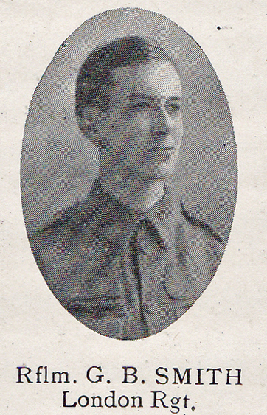
Source: The Fullerian WBGS
George Boreham Smith, born on 8 February 1898 in Bushey, was the son of Thomas Bryant Smith. His father, who had been widowed and already had a family, married Martha Boreham, George’s mother, in 1894. In 1901, when George was four, the family was living at 1 Bushey Grove Road and Thomas Bryant Smith was an ironmonger. In 1908 George attended Watford Boys’ Grammar School for a year but then the family moved away from Hertfordshire to 48 Springfield Road, Guildford.
By 1911 his father was 75 and had retired. George, who was then 14, was employed as a surveyor’s clerk. George’s father died in 1913 and George and his mother returned to Bushey to live at ‘Boreham Lodge’, 14 Bushey Grove Road.
George enlisted with the London Regiment and served as Rifleman 474299 in France and Flanders. He was killed in action on 24 June 1917, aged 21 and is remembered with honour at Wancourt British Cemetery in France. His widowed mother died In Bushey and no-one put his name forward for the Bushey memorial.

