**John Richard Gutteridge Smith**



John Richard Gutteridge Smith was born in Watford on 21 February 1890. His father, Joseph Gutteridge Smith, was a retired paper manufacturer at Hampermill, Oxhey, living on his own means. Joseph Gutteridge Smith was married twice, firstly to Mary Elizabeth Hepburn, with whom he had a son and five daughters. They lived initially in Watford High Street and later at Hamper Mill House. Mary died in 1885 and in 1887 Joseph married Isabel Roots, with whom he had four more children, two sons and two daughters. John was the second son of this marriage. The 1891 census shows the family living at Wiggen Hall House, Oxhey, with three servants. Wiggen Hall House had 18 rooms and a walled garden leading down to the River Colne. It was demolished in the 1950s. John was educated at Milton House School and by private tutors. The 1911 census records him as a student. His father died in 1914 at the age of 92.

John joined the Artists’ Rifles in August 1915 and obtained a commission as 2nd Lieutenant. Home on leave on 7 September 1916, he married Elsie Marjorie Ferryman in Watford. He died three months later at Le Touquet on 30 December 1916, aged 26, of wounds received in action at the Battle of the Somme. He is commemorated at Etaples in France, on the St Matthew’s Church memorial and on a special plaque in the church.

[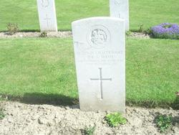](http://www.findagrave.com/cgi-bin/fg.cgi?page=pv&GRid=10897746&PIpi=16210743)

Grave of John Richard Gutteridge Smith

[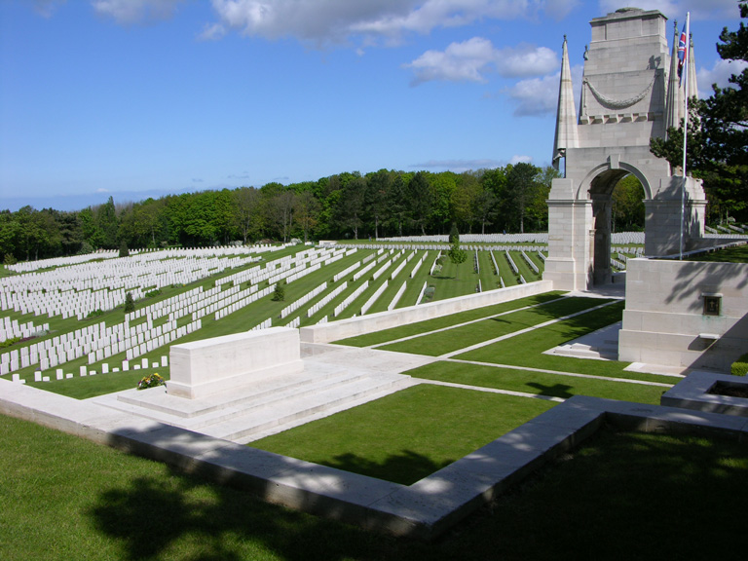](http://www.cwgc.org/dbImage.ashx?id=5833)