Reginald Frederick Smith
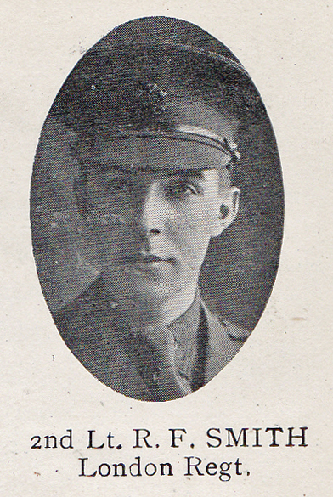
Source: The Fullerian WBGS
Reginald Frederick Smith, born on 8 February 1898, was the eldest son of Reginald and Ellen Smith, who moved to Watford from Croydon, Surrey soon after Reginald was born. His father was a motor repairer and the family lived at 9 Salisbury Road, Watford. Reginald had three younger siblings, Roy, Terence and Dorothy and at the time of the 1911 census, he was 13. From 1909 until 1915 he was a pupil at Watford Boys’ Grammar School.
He gained a commission as Second Lieutenant in the 15th Battalion of the London Regiment (Prince of Wales’ Own Civil Service Rifles) and served on the Western Front. He died on 14 May 1917, aged 19 and is remembered with honour on the Arras Memorial in France. After the war his parents moved to ‘Arle’, Cedar Road, Oxhey.

