Thomas Daniel Josiah Snare
Thomas Daniel Josiah Snare was born in Bushey on 27 September 1873, one of seven children of Robert and Harriet Snare. His father, the son of a flint merchant from Suffolk, came to Hertfordshire in the late 1850s and found employment with a linen draper in Watford High Street. In 1862 he married and he and his wife, Harriet, moved to Bushey village, where he took over an established drapery business in the High Street. The shop was on the corner of Cow Lane, where ‘Mavis’, the wool and art needlework shop, stands today. Robert and Harriet’s children were all born in Bushey and the family became well known in the local community. The business flourished and Robert Snare adapted to the changing times. The coming of the Herkomer Art School in the 1880s provided new trade and he seized the opportunity to expand.
Thomas Daniel Josiah Snare spent his childhood in Bushey and was educated at Watford Boys’ Grammar School from 1884 to 1888.
By the age of nineteen he had left home and was employed as a draper’s assistant to John King, draper and outfitter, at 36 Bromley High Street in Kent. On18 November 1898 he married Alice Gertrude Nightingale, a dressmaker from Tonbridge, at Bromley parish church. By 1901 Thomas was the manager of a clothier’s shop in the town and he and Alice lived at 58 Park End, Bromley. Their first son, Robert Cecil, was born there on 27 December 1899.
Meanwhile his father’s business at 44 Bushey High Street had prospered and Robert Snare set up another shop at 4 & 5 Church Row, Stanmore, Middlesex, about three miles from Bushey. In about 1903 Thomas returned from Kent to manage this shop and his wife and her sister, Winifred Nightingale, helped with the business. Two more children were born there, Reginald Thomas on 13 August 1903 and Mildred Gertrude on 10 April 1908. The family employed one female servant. In 1913, however, The London Gazette recorded that on 1 March the business in Stanmore ceased trading and was in the hands of a London receiver.
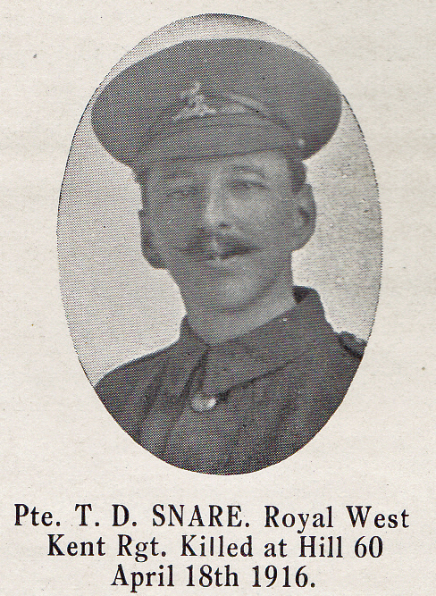
Source: The Fullerian WBGS
When war broke out the following year Thomas was 41 so on 1 January 1915 he took a short service enlistment at Mill Hill as Private with the Royal West Kent Regiment. He gave his occupation at G/5171 that time as a car man. He was reported missing assumed killed in action in France on 18 April 1915, aged 42. He is commemorated at the Menin Gate memorial to the Missing. His wife, Alice, received the standard medals awarded to all servicemen in 1920 and 1921. He is not commemorated on any of the Bushey memorials. Alice died in Maidstone in 1945, aged 68.

