Robert Eliot Stavert
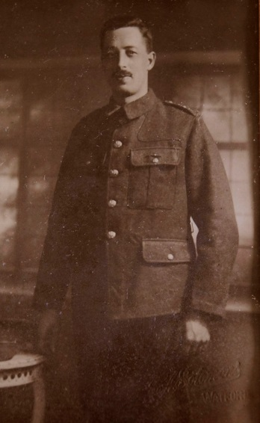
Robert Eliot Stavert, born in Bushey on 17 December 1886, was the son of Robert and Annie Stavert of 3 Bournehall Road, Bushey, who had seven children, three of whom died in childhood. His father, a railway clerk, was considerably older than his mother and died in 1899. At the age of fifteen Robert was employed by the London and North Western railway at Euston station and worked in various departments until 1916. In his spare time was a regular bell ringer at St James’ Parish Church. He married Mary Winifred Arnold in 1912. By 1915 his mother had moved to 14 King Edwards Road, Oxhey.
During the war he joined the London Royal Fusiliers and gained a commission. He served as a Captain and was killed in action on 25 August 1918, aged 31. He is remembered with honour at Bucquoy Communal Cemetery Extension in France. He is commemorated on the Bushey Memorial, at St James’ Parish Church and at St Matthew’s Church, Oxhey. His wife later lived at 6A Ye Corner, Aldenham Road, Oxhey. His younger brother, George James Stavert, in the Royal Naval Volunteer Reserve, died at Gallipoli in 1915.

