Harry John Stockman
Harry John Stockman, born in 1890 in Islington, was the son of Herbert and Emma Stockman of 34 Park Road, Bushey. His father was a store man for the GPO and Harry was one of nine children, four of whom died in childhood. In 1911, aged 24, Harry was employed as a labourer at a local print works. He married Lily May Poplett of 14 Park Road, Bushey, in 1916.
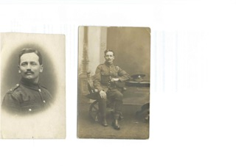
Harry enlisted at Watford with the Royal West Kent Regiment and served as Lance Corporal G/36743 in France and Flanders. He was killed in action on 14 September 1918, aged 28. His death was recorded in The Herts Mercury on 12 Oct 1918:
A letter of sympathy from an officer states that the deceased was a very gallant soldier and his company commander, who was killed in action a few days previously, had a very high opinion of him.
Harry Stockman is remembered with honour at Vis-En-Artois Memorial in France and is commemorated on the Bushey Memorial and at St James’ Parish Church in Bushey.
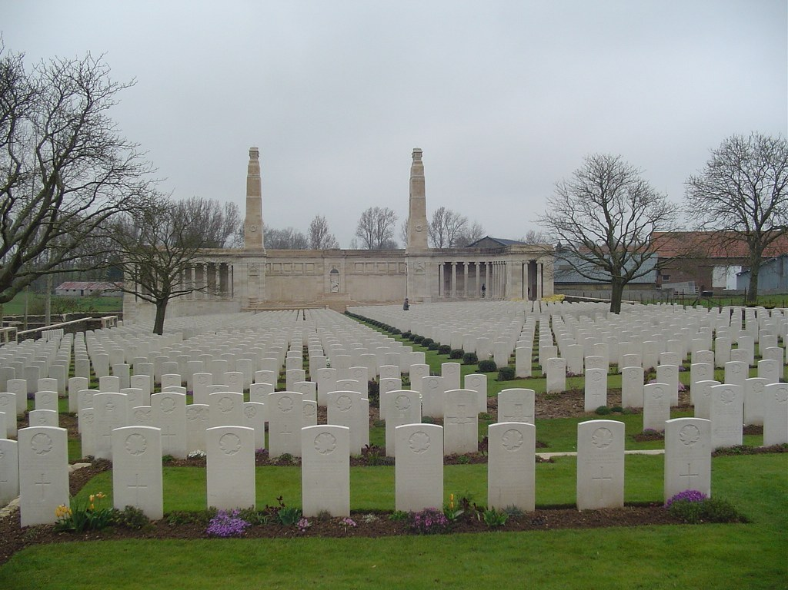

Harry John Stockman
Age in 1911: | 21
Estimated Birth Year: | abt 1890
Relation to Head: | Son
Gender: | Male
Birth Place: | Islington, London, England
Civil Parish: | Bushey
County/Island: | Hertfordshire
Country: | England
Street Address: | 34 Park Road, Bushey
Marital Status: | Single
Occupation: | Labourer Printing
Registration District: | Watford
Registration District Number: | 140
Sub-registration District: | Bushey
ED, institution, or vessel: | 9
Household Schedule Number: | 203
Piece: | 7695
Household Members: | Name Age  Herbert Joseph Stockman 47  Emma Stockman 48  Harry John Stockman 21 labourer printing  Edwin Thomas Stockman 18  Florence Nellie Stockman 17  Arthur Victor Stockman 13  Alfred Leslie Stockman 9

STOCKMAN, HARRY JOHN 14, Park Road, husband of Lily May Stockman (nee Poplett) L Corp G/36743 Royal West Kent 28 14/09/1918 CWGC Vis-en-Artois BM SJ Death recorded in SJ Parish Magazine m 11 Jan 1916
Harry John Stockman
Date of Registration: | Apr-May-Jun 1890
Registration District: | Islington
Inferred County: | London
Volume: | 1b
Page: | 352

Harry J Stockman  Age: 11  Estimated Birth Year: abt 1890  Relation to Head: Son  Gender: Male  Father: Herbert F Stockman  Mother: Emma Stockman  Birth Place: Islington, London, England  Civil Parish: Bushey  County/Island: Hertfordshire  Country: England  Street Address: Occupation: Condition as to marriage: Education: Employment status: View Image  Neighbors: View others on page  Household Members: Name Age Herbert F Stockman 36 Emma Stockman 37 Harry J Stockman 11 Edwin T Stockman 8 Florence N Stockman 7 Arthur V Stockman 3 | View  Original  Record  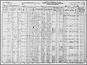  View original image
Harry John Stockman
Birth Place: | Islington, Middx.
Residence: | Bushey, Herts
Death Date: | 14 Sep 1918
Death Location: | France & Flanders
Enlistment Location: | Watford, Herts
Rank: | L/Corporal
Regiment: | Queen's Own (Royal West Kent Regiment)
Battalion: | 2/20th London Regiment
Number: | G/36743
Type of Casualty: | Killed in action
Theatre of War: | Western European Theatre
Comments: | Formerly T/4/107956, R.A.S.C

Father storeman for GPO

STOCKMAN, HARRY JOHN 14, Park Road, husband of Lily May Stockman (nee Poplett) L Corp G/36743 Royal West Kent 28 14/09/1918 CWGC Vis-en-Artois BM SJ Death recorded in SJ Parish Magazine m 11 Jan 1916

His father remained in Bushey but later became the publican at The Cock Inn, Colney Heath, St Albans.

