**Percival Edward Tarver**



Percival Edward Tarver was born in about 1873 at Eton College, Berkshire, where his father, William H. Tarver, taught French for many years. On retirement, his parents moved to Bushey and established a family home at ‘The Bungalow’, Bournehall Road. Percy, as he was known, had five older sisters and a younger brother. Three of his sisters were artists who attended the Herkomer Art School in Bushey and their art studio is still at the bungalow in Bournehall Road.

Percy completed his education and went abroad to work for the Argentine Railway. When war broke out he returned and enlisted as a Private with the London Territorials. He served in France with the London Regiment, 13th Kensington Battalion, where his duties as a signaller included carrying messages on foot and by bicycle or by leaving the road and crawling along trenches in deep mud. In January 1915, he wrote to *The Watford Observer* describing his experiences and the Christmas Truce of 1914. He was killed in action on 12 March 1915, aged 42. He was buried at Neuve-Chapelle Farm Cemetery in France and is commemorated in Bushey on the Clay Hill Memorial and at St James’ Parish Church.

[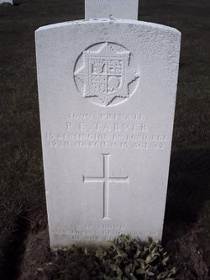](http://www.findagrave.com/cgi-bin/fg.cgi?page=pv&GRid=59115021&PIpi=91015881)