Henry Cedric St John Thompson

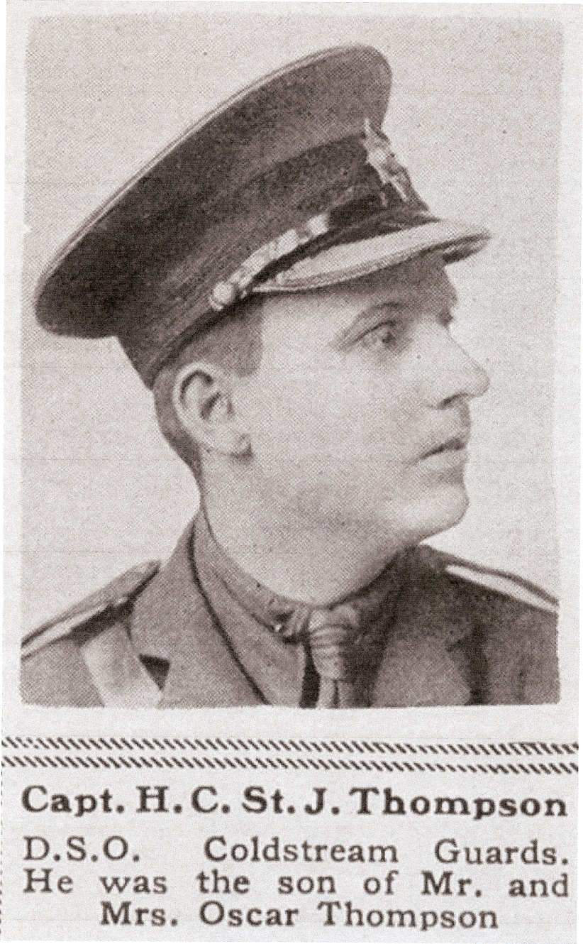

Henry Cedric St John Thompson, born in about 1888 at ‘The Warren’ in Bushey Heath, was the elder son of Harvey St John Oscar Thompson and Lilian Steinmetz, both of Bushey Heath, and grandson of Henry Thompson of ‘The Warren’. Both Henry senior and Oscar Thompson were colonial tea brokers and made substantial donations to St Peter’s Church, Bushey Heath. Henry and Lilian Steinmetz had a house in London, where they employed seven servants and a governess, who prepared their two sons for school. They were frequent visitors to ‘The Warren’. Henry was educated at Stone House Prep School, Broadstairs and at Eton.
In 1914 he gained a commission as 2nd Lieutenant in the Corps of Interpreters and later transferred as a Captain to the Coldstream Guards. His DSO was awarded for gallantry in the advance to Broembeck.
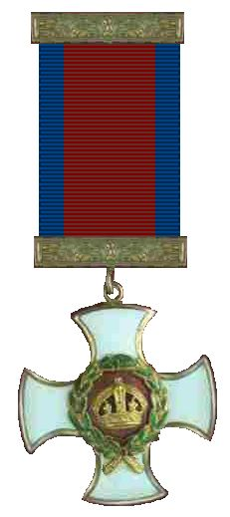

He was mortally wounded at Gouzeaucourt on 30 November 1917 and died a few minutes later, aged 29.
He is not commemorated in Bushey Heath but is named on the memorial at St James Church, Spilsby in Lincolnshire, where his uncle, Rev Bernard Steinmetz, was for a time the vicar.

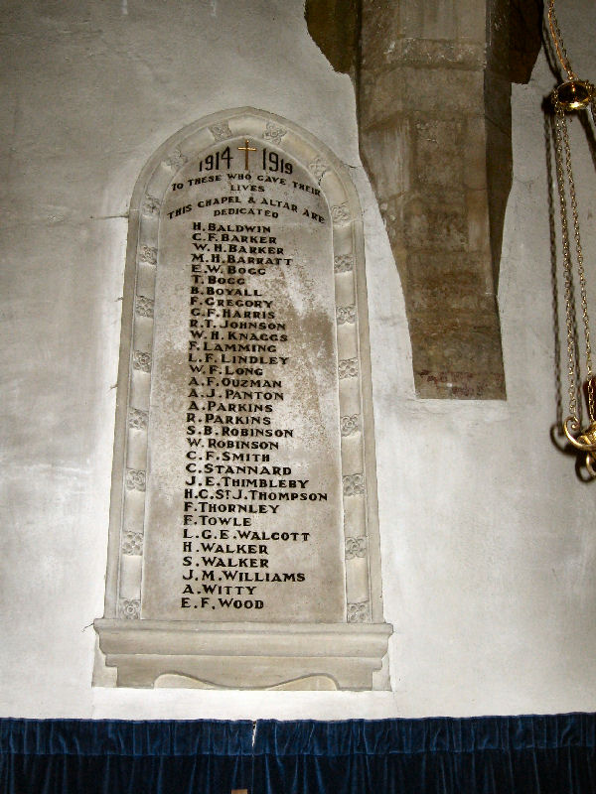

St James’ Church, Spilsby, Lincolnshire
Photograph by Michael Peck 2007

