Cyril Sidney Merralls Vale
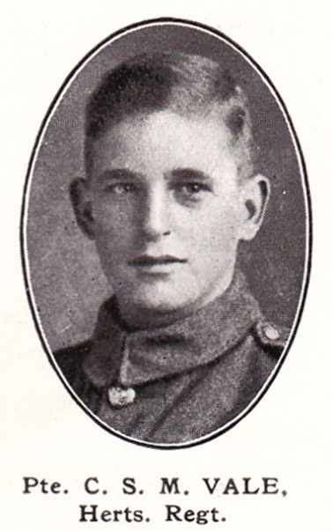
Source: The Fullerian WBGS
Cyril Sidney Merralls Vale, born in Oxhey on 13 June 1899, was the youngest son of Reynold and Elizabeth Vale. His father ran a grocery store at 35 Chalk Hill, Oxhey. In 1901 his elder brother, Reynold Watson Vale, who was sixteen, was already helping in the family business but when Cyril was about six, their mother died. His brother, Reynold, married and he and his wife joined the family at 35 Chalk Hill and both helped in the grocery business. The family employed one servant.
Cyril was educated at Watford Boys’ Grammar School from 1907 to 1914.
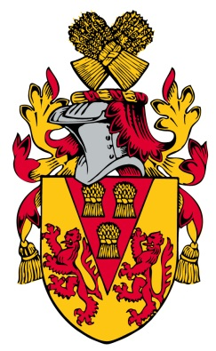
When war broke out, he enlisted at Watford as Private 42002 in the 1St Battalion of the Hertfordshire Regiment. He served throughout the war and died of wounds received at Aveluy Wood on the Western Front, aged 19. He is remembered with honour at Terlincthun British Cemetery, Wimille in France. He is commemorated at the memorial at St Matthew’s Church, Oxhey.

