Leonard Varley

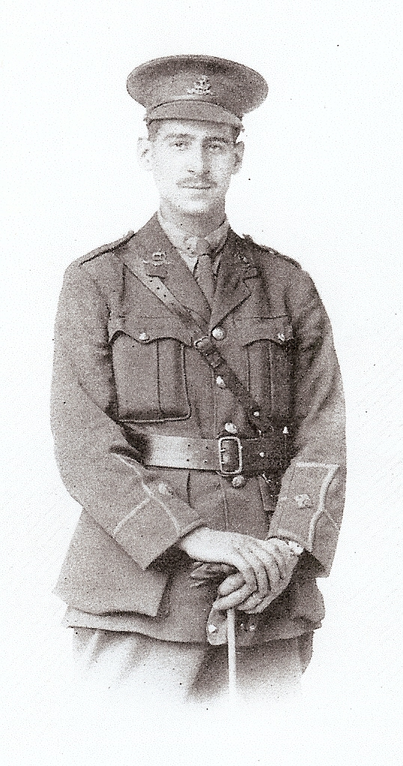

Leonard Varley, born on 20 March 1893, was the son of George and Sarah Varley, of 44 Leyburn Grove, Bradford Road, Shipley, Yorkshire. He joined The Royal Masonic School in Bushey to teach Modern Languages in June, 1914, so he had been in his post little more than a month when war broke out.

He was educated at Belle Vue Higher Grade School. At twelve years of age he won scholarships to Bradford Grammar School and to the Saltaire Higher
Grade School, but he did not take them up. When he was sixteen he won the first ‘Isaac Holden’ Scholarship to Cambridge, but as he was too young to go up then he went as exchange tutor in English to Rodez College in France. In 1911 he went to Trinity College, Cambridge and then directly to The Royal Masonic School in Bushey in 1914.

He had been a member of the University O.T.C., and on 26 August, 1914, he joined the 6th Battalion, Duke of Wellington's West Yorkshire Regiment as Second Lieutenant. He was promoted full Lieutenant on I June, 1915. He took part in fighting near Ypres and met his death there on 11 November 1915, aged 21. It was his last night in the trenches, as he was due out for a rest, when he was killed while returning from examining gun positions. A career full of brilliant promise was cut short, for he possessed exceptional ability and everything he took in hand he seemed to accomplish with little effort. He had an affectionate and cheerful disposition which was also characterised by great unselfishness. He was buried at Bard Cottage Cemetery, west of Ypres.
Source: Memorials of Masonians who fell in the Great War (1922)

He is commemorated on the Bushey Memorial.

