Daniel James Christopher Veresmith

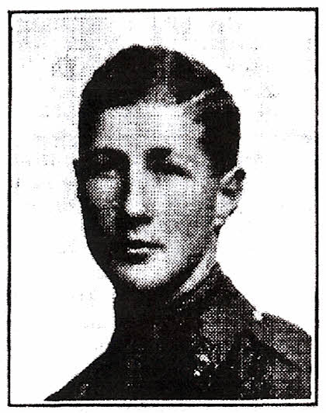

Daniel James Christopher Veresmith born in Bushey on 25 March 1894, was the third son of Daniel Albert Wehrschmidt and his Scottish wife, Maria Louise. His father, the son of a German immigrant tailor to America, lived near Cleveland, Ohio, before coming to England, where, as an artist, he became a tutor at the Herkomer Art School in Bushey. Daniel and Louisa lived firstly at ‘Cleveland’, Bushey High Street, named after his father’s homeland and now part of St Hilda’s School. They then moved to Rose Cottage, Elstree Road, Bushey Heath.

He was educated at Blackheath Proprietory School and Edinburgh Academy, where he was a member of the OTC and shot twice in the School Eight at Bisley in the Public Schools Challenge Cup. The family changed their names to Veresmith before the war because of anti- German attitudes. Daniel joined the Lothian and Border Yeomanry as a Trooper, obtained a commission as 2nd Lieutenant in the Lowland Brigade on 29 April 1914, and was promoted Lieutenant on 24 January 1915. On the outbreak of war in August 1914 he volunteered for foreign service. He served with the Expeditionary Force in France and Flanders until October 1915. He died at No. 30 Casualty Clearing Station on14 April, 1917, from wounds received in action at Vimy Ridge on the 11April. He was buried at Aubign en-Artois Communal Cemetery. His Commanding Officer wrote:

His battery was one of the first to move forward into the territory captured during the big attack of 9 April. Your son had been placed in command of the guns. We had the greatest confidence and admiration for your son, who was immensely popular with all ranks, and an artillery subaltern of the highest rank.

A brother officer wrote:

He was always so cheery, so good-natured and so willing and anxious to help anyone, that no matter how trying or depressing the circumstances were, one couldn't help seeing the' silver lining in every cloud.'

His parents moved to ‘Abbotsbury’, Mottingham in Kent so his name is not on any Bushey memorial.
His older brother, Evelyn Henry Veresmith, died of wounds received at the Somme on 9 July 1916.

