Evelyn H Veresmith
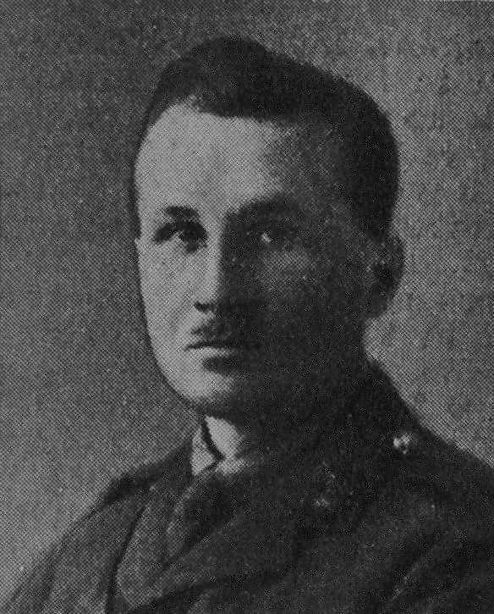

Evelyn H Veresmith was the son of Daniel Wehrschmidt, tutor at the Herkomer Art School, who changed his name before the war because of anti-German attitudes. He joined up at the beginning of the war and died at No 5 casualty clearing station on 9 July 1916 from wounds received in action between Albert and Pozieres at the Battle of the Somme.
His Commanding Office wrote to his parents: ‘The battalion was ordered to attack and your son gallantly got out of the trench and led his platoon, but was soon seriously wounded and died two days later. He was a gallant young officer, and I am very sorry for you. Our brigade made a very successful and important gain, so you must think of your son’s death as a glorious end’.
Source : De Ruvigny's Roll Of Honour Vol 2
His brother, Captain Daniel J C Veresmith also fell on 14 April 1917.

