Henry Vincent

Henry Vincent, born in Watford in 1882, was the son of Herbert Alfred Vincent and his wife Flora. Henry was their only son and he had two younger sisters. His father was an agent for a foreign silk manufacturer and in 1891 the family home was ‘Batavia’, Bushey Hall Road. His father died in 1897 at the age of 38 and by 1901 the family had moved to West Ham, where Henry was employed at a silk merchant’s warehouse.

By 1911 he was married to Florence Amelia Ellis and they had made their home in Devonshire Road Forest Hill. They called their house ‘Batavia’. Henry was now employed as a travelling salesman in fashion publishing and printing. His wife’s brother, in a similar occupation, lived with them.

Henry enlisted in Lewisham as Private 353290 in the London Regiment. He served in France and Flanders and was awarded the Military Medal, a decoration awarded to service men below commissioned rank, for bravery in battle on land.

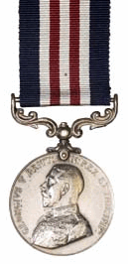

He was killed in action on 25 April 1917, aged 36. He is remembered with honour at Chester Farm Cemetery in Belgium.

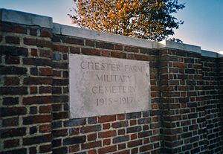

After his death his wife moved to Brighton. He is not commemorated on a Bushey memorial.

