Frank Trevor Wakeman
Frank Trevor Wakeman, born in Sutton Coldfield, Warwickshire, in 1899, was the eldest son of Frank John Wakeman and Edith Margaret Wakeman. His father was an insurance manager and the family lived initially at ‘The Dene’, Four Oaks, Warwickshire.
By 1911 they had moved to Hertfordshire and their address was ‘The Dene’, Grange Road, Bushey (now numbered 28) At the time of the 1911 census, Frank’s two younger brothers, John Dennis Wakeman, aged nine, and Arthur Stuart Wakeman, aged just a year and born in Bushey, were living at ‘The Dene’, Grange Road with two servants and ‘a gentlewoman visitor’. Frank and his parents may have been abroad.
Frank enlisted with the London Regiment, later transferring to the 5th battalion of the Royal Warwickshire Regiment. He then joined the 4th squadron of the Royal Flying Corps where he became a Lieutenant. He was killed on 30 October 1917 and is remembered with honour at the Arras Flying Service Memorial, which commemorates almost 1,000 airmen of the Royal Naval Air Service, the Royal Flying Corps, and the Royal Air Force, who were killed on the Western Front and who have no known grave.
Frank Wakeman is commemorated on the Bushey memorial and at St Paul’s Church, Bushey. His parents continued to live at ‘The Dene’, Grange Road until about 1915 and then moved to 48 Gracechurch Street, E C London.
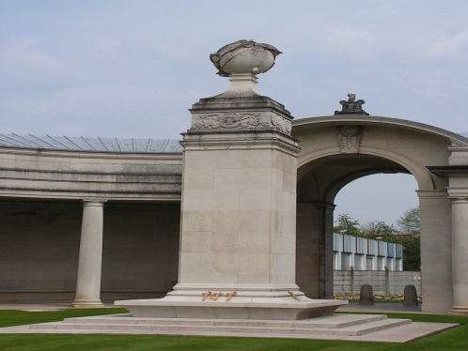

‘Lieutenant Frank Trevor Wakeman, Royal Warwickshire Regiment and Royal Flying Corps, was the eldest son of Mr and Mrs Frank T Wakeman of ‘The Dene’, Grange Road Bushey. He was educated at Cambridge House School, Margate and West Buckland School, North Devon. He joined the Artists Rifles in April 1915 and was gazetted a 2nd Lieutenant in the Royal Warwickshire Regiment in October. He went to France the following December and was severely wounded in Feb 1916. After six months in hospital and convalescence, he rejoined his regiment and was shortly afterwards transferred to the Royal Flying Corps. He spent the winter of 1916 -17 in Egypt and on returning to this country in May obtained his ‘wings’ and in the same month went to the Front. He was promoted to Lieutenant in July, in which month he was again wounded. His flight commander speaks of him as a valuable pilot’.

Flight 8 November 1917
www.flightglobal.com

