Alfred William Waldron

Alfred William Waldron, born in 1887, grew up in the Berkhamsted area. His parents, Joseph and Annie Waldron, lived initially in Northchurch, a village between Berkhamsted and Tring, where Joseph was employed as a domestic gardener. Joseph and Annie had four sons and an adopted daughter, Ada Maria West. Alfred was the oldest and by 1901, when the family had moved to 51 Gossom End, Northchurch, he had left school and was working as a warehouse boy. By the time of the 1911 census, he was still living at home at 2 William Street, Berkhamsted, employed as a landscape gardener. In the summer of 1911 he married Esther Mary Bond and they had a daughter. When Alfred enlisted for war service in 1915 they had settled in Bushey at 119, School Lane. Albert enlisted at the age of 28, and was promoted to the rank of Corporal in The Buffs (East Kent Regiment) G/10206. He was killed in action on 23 October 1918 and was buried in Forest Communal Cemetery in northern France. He is commemorated on the Bushey Memorial and at St Peter’s Church, Bushey Heath.

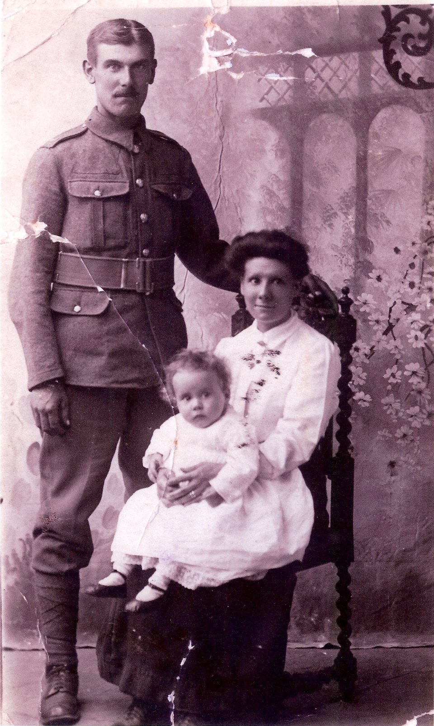
Alfred Waldron with his wife, Esther, and their daughter, Barbara May
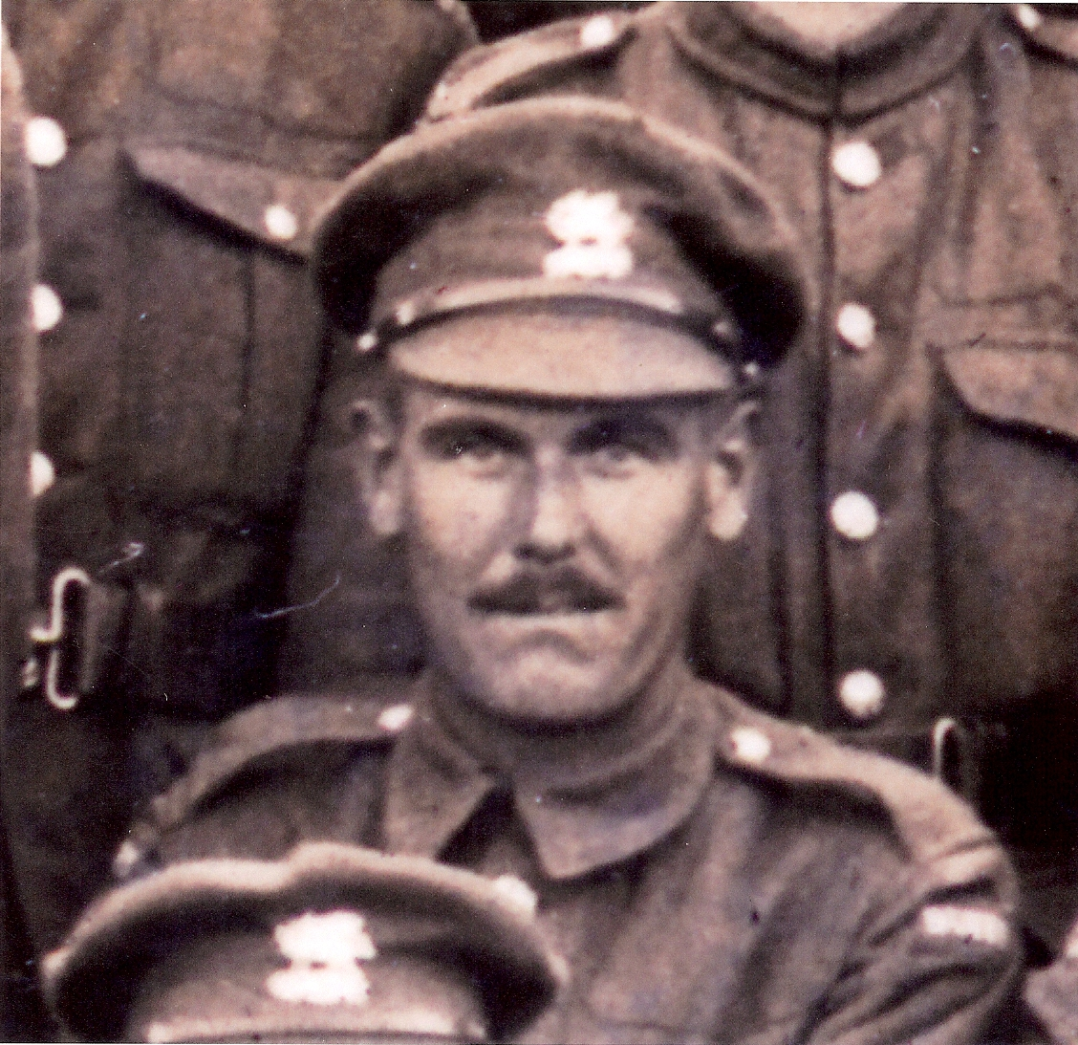
Alfred Waldron in The Buffs (East Kent Regiment)
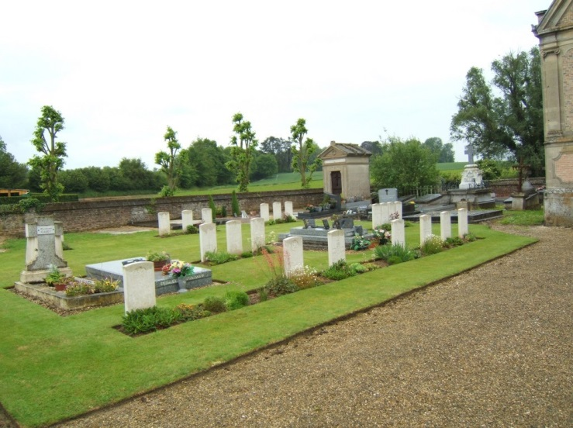
Forest Communal Cemetery, France

