Fred Ward
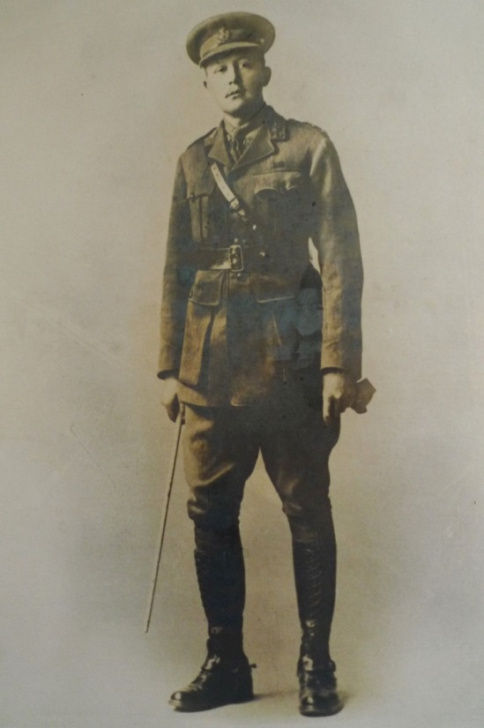
Fred Ward, born in 1884 was the son of Charles Ward and Hannah Baldwin of St Pancras, London, where he was baptised on 10 February that year. He grew up at 12 Burton Street, St Pancras, in a family of six children. His father and uncle worked as artists’ colour grinders for James Newman, Artists’ Colourer of 24 Soho Square. Newman’s, established in the late 18th century, ground colours by hand and supplied a wide range of materials to many famous artists. In 1914 they made ‘useful new shades in Hand-made Tinted Paper for Water Colour Painting'. Fred also worked for James Newman as a colour man’s assistant and in 1901 was employed by the British Museum.
On 22 April 1905, at the age of 21, Fred married Lilian Hendley at the Parish Chapel, St Pancras. They had 2 children, Doris Beatrice, born in 1908, and Ena Lilian, in 1911. At that time they were living at 8 Burton Street, a few doors away from the Ward family home. Between the 1911 census and 1915, the family moved to Hertfordshire and settled at 56 Glencoe Road, Bushey. Their address is confirmed in the 1915 Peacock’s Directory. Perhaps Fred had been attracted to Bushey by the colony of artists living there and saw opportunities for retail trade.

Fred Ward’s military records show that he enlisted initially with the 9th London Regiment and became a Company Sergeant Major number 3281. He later transferred to the 2nd/19th London Regiment and rose to the rank of Captain. He won the Military Cross and was mentioned in despatches. He was killed in action in Palestine on 8 December 1917, aged 33. He was buried in the Jerusalem War Cemetery, grave reference U117.

His wife, Lilian, left Bushey and settled with her children at 105, Weston Park, Hornsey, London, N8. Fred is commemorated on the Bushey Memorial on Clay Hill, at St James’ Parish Church and at St Pancras Church in London.

*********
Diane Livesey, the great niece of Captain Fred Ward, brought his military details and photograph to the Bushey WW1 exhibition ‘A Village Remembers’. Members of our research team confirmed that her great grandfather was the F Ward living at 56 Glencoe Road, Bushey in 1915 and that it was his name on the Bushey Memorial and at St James’ Church.
Research has also brought to light a letter that Captain Fred Ward wrote to the mother of Glasgow-born Lt Edwin Schonfield, 2/19th London Regiment, a Jewish soldier under his command,who was killed on 2 September 1916, aged 26.
I have had your boy with me for three months now. He is a terrible loss to me. My respect for him I cannot express, his cool enduring courage, his personal example and his ever-cheerful disposition, were to us such a blessing and an asset, we can never replace him. Mr. Harris of my company [probably 2nd Lt George Harris] has gone out to see him buried and make the best arrangements possible to fulfil the requirements of your religious faith. Mr. Harris is a Jewish soldier and a good fellow. I immediately wrote to the Jewish Chaplain of the Forces to officiate: fortunately he was in a town about five miles away. I have instructed Mr. Harris to do all he thinks you would require, also to arrange for a suitable tablet to be erected so that you will be able to make later arrangements. Pray, tell me if there is anything I can do for you, I am at your service. I cannot do too much for him, he has done so much for me. As one example of his unselfishness, he was good enough to allow me, though his junior, to supersede him. He then asked to come into my company.
http://www.hellfirecorner.co.uk/snillopofficers.htm

