Reginald Alexander John Warneford VC

Reginald Alexander John Warneford was born at Darjeeling, India, on 15 October 1891, the son of an engineer on the Indian Railways. He was brought to England as a small boy and educated at King Edward VI School, Stratford-upon-Avon but when his family returned to India he continued his education at the English College, Simla.

Following apprenticeship in the merchant marine, Warneford joined the British-India Steam Navigation Company. At the time of the outbreak of World War I, he was in Canada awaiting return to India. Instead, he sailed then to Great Britain, joining the Army but almost straightaway transferred to the Royal Navy Air Service for pilot training.

Warneford's initial training took place at Hendon, passing then to Upavon where he completed his pilot training on 25 February 1915. During the course of training, the Commander of Naval Air Stations, R. M. Groves was quoted as saying: "This youngster will either do big things or kill himself." Warneford's flying instructor at the time, Warren Merriam, noted his skills as a pilot but had to make special arrangements to ensure that Warneford's perceived over-confidence did not bar him from attaining a commission. Merriam took an opportunity whilst Commander Groves was visiting Hendon to ask Warneford to demonstrate his flying skills. Groves' favourable impression overcame the views of the Squadron Commander at the time who believed that Warneford would never make an officer because of his lack of concern for disciplinarian matters.

Warneford was initially posted to 2 Wing on the Isle of Sheppey in Kent but was quickly (7 May 1915) posted to an operational unit with 1 Wing at Veurne on the Belgian coast. Over the next few weeks, Warneford was involved in attacks on German troops and guns, as well as actions against enemy aircraft. His aggressiveness and effectiveness led to his being given his own aircraft and a roving commission.
On 17 May 1915, Warneford encountered Zeppelin Airship LZ39 setting out on a raid over Britain. He attacked LZ39 with machine gun fire but the airship was able to ascend out of range by jettisoning ballast.

Warneford was 23 years old, and a Flight Sub-Lieutenant in the Royal Navy's 1 Squadron, RNAS when the following action took place for which he was awarded the VC. On 7 June 1915 at Ghent, Belgium, Warneford, flying a Morane-Saulnier Type L, attacked and completely destroyed the German airship LZ37 in mid air. He had chased the airship from the coast near Ostend and, despite its defensive machine-gun fire, succeeded in dropping his bombs on it, the last of which set the airship on fire. The explosion overturned the attacking plane and stopped its engine. Having no alternative, Warneford had to land in hostile country, but after 35 minutes spent on repairs, he managed to restart the engine and returned to base.

On 17 June 1915, Warneford received the award of Légion d'honneur from the French Army Commander in Chief, General Joffre. Following a celebratory lunch, Warneford travelled to the aerodrome at Buc in order to ferry an aircraft for delivery to the RNAS at Veurne. Having made one short test flight, he then flew a second flight, carrying an American journalist, Henry Beach Newman, as passenger. During a climb to 200 feet, the right wings collapsed leading to a catastrophic failure of the airframe. Accounts suggest that neither occupant was harnessed and were thrown out of the aircraft, suffering fatal injuries. In the case of Newman, death was instantaneous. Warneford died of his injuries on the way to hospital.
He was buried at Brompton Cemetery, London on 21 June 1915 in a ceremony attended by thousands of mourners.

His Victoria Cross is displayed at the Fleet Air Arm Museum.

Warneford Place, off King Edward Road, Oxhey, was named after him. His step mother lived in Oxhey Avenue and his aunt in Kingsfield Road. In St Matthew’s Church, Oxhey a tablet reads:
To the Glory of God and in memory of Flight Sub-Lieut R A J Warneford VC Chavalier Legion D’Honeur RN, who attacked and destroyed a Zeppelin airship June 7th 1915 and was accidentally killed when flying in France June 17th 1915. This tablet was erected by the people of Oxhey.

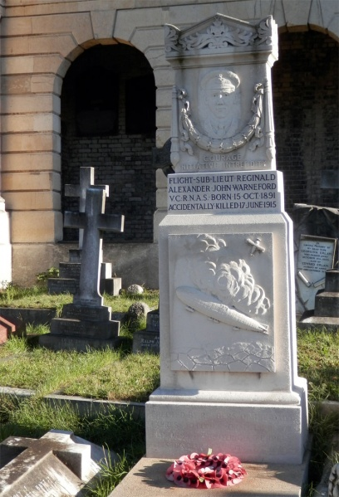
Memorial in Brompton Cemetery
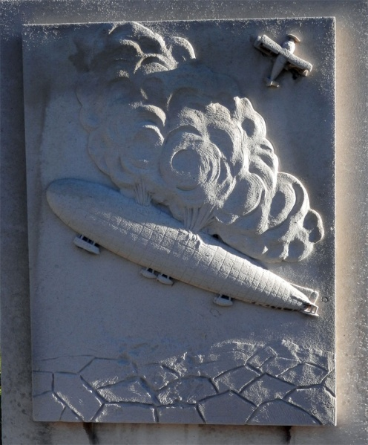
Memorial detail
Warneford’s battle report:
Sir, I have the honour to report as follows : I left Furnes at 01.00 am on June 7th on Morane No 3253 under orders to proceed to look for Zeppelins and attack the Berchem Ste. Agathe airship shed with six 20 lb bombs. On arriving at Dixmude at 01.05 am I observed a Zeppelin apparently over Ostend and proceeded in chase of same. I arrived at close quarters a few miles past Bruges at 01.5à am and the airship opened heavy maxim fire, so I retreated to gain height and the airship turned and followed me. At 2.15 he seemed to stop firing and at 2.25 am I came behind, but well above the zeppelin; height then 11,000 feet, and then switched off my engine to descend on top of him. When close above him, at 7,000 feet I dropped my bombs, and, while releasing the last, there was an explosion which lifted my machine and turned it over. The aeroplane was out of control for a short period, but went into a nose dive, and the control was gained. I then saw that the Zeppelin was on the ground in flames and also that there were pieces of something burning in the air all the way down.
The joint on my petrol pipe and pump from the back tank was broken, and at about 2.40 am I was forced to land and repair my pump.
I landed at the back of a forest close to a farmhouse; the district is unknown on account of the fog and the continuous changing of course. I made preparations to set the machine on fire but apparently was not observed, so was enabled to effect a repair, and continued at 3.15 am in a south westerly direction after considerable difficulty in starting my engine single handed.
I tried several times to find my whereabouts by descending through the clouds, but was unable to do so. So eventually I landed and found out that I was at Cape Gris-Nez, and took in some petrol. When the weather cleared I was able to proceed and arrived at the aerodrome about 10.30 am. As far as could be seen the colour of the airship was green on top and yellow below and there was no machine or gun platform on top.
I have the honour to be, Sir, Your obedient servant,
R.A.J. Warneford. Flt. Sub-Lieutenant.
The official text on his VC :
On 7 June 1915 at Ghent, Belgium, Flight Sub-Lieutenant Warneford attacked and completely destroyed a German airship in mid air. He had chased the airship from the coast near Ostend, and succeeded in dropping his bombs on it, the last of which set the airship on fire, but the explosion overturned the attacking plane and stopped its engine. Having no alternative, Flight Sub-Lieutenant Warneford had to land in hostile country, but after 35 minutes spent on repairs, he managed to restart the engine and returned to base.
http://www.forumeerstewereldoorlog....ghlight=&sid=68bfaa704ef51c28ad6fe13d3f7f1d4e

