Clement Spencer Watson
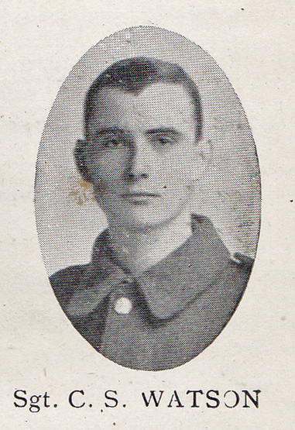
Source: The Fullerian WBGS
Clement Spencer Watson, the elder son of Clement and Mary Watson of 77, Upper Paddock Road, Oxhey, was born in Buckinghamshire on 28 September 1895. His father was a poultry manager in Buckinghamshire but in the early 1900s he moved his family to 77, Upper Paddock Road in Oxhey and became a journalist, writing for the poultry press. Clement attended Watford Boys’ Grammar School from 1907 until 1912.
When war was declared, Clement enlisted at Handel Street in Bloomsbury and served as Sergeant 201013 in the London Regiment. He died of wounds on 18 May 1917 at the age of 21 and is buried at Achiet-le-Grand Communal Cemetery Extension and is commemorated on the memorial at St Matthew’s Church. Oxhey. His younger brother, William Neville Watson, also died of wounds in 1918.
