William Neville Watson
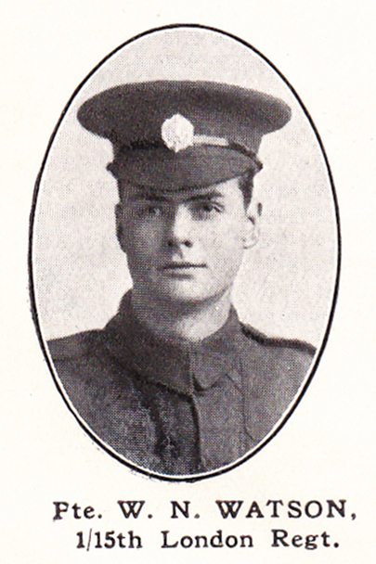
Source: The Fullerian WBGS
William Neville Watson, the younger son of Clement and Mary Watson of 77, Upper Paddock Road, Oxhey, was born in Buckinghamshire on 22 June1899. His father was a poultry manager in Buckinghamshire but in the early 1900s he moved his family to 77, Upper Paddock Road in Oxhey and became a journalist writing for the poultry press. William attended Watford Boys’ Grammar School from 1911 until 1915.
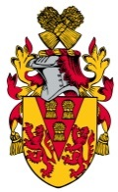
He enlisted in Whitehall as Private 548135 in the Civil Service Rifles, London Regiment. He served on the Western front and died of wounds on 26 August 1918 at the age of 19. He was buried at Daours Communal Cemetery Extension on the Somme. He is commemorated on the memorial at St Matthew’s Church. His elder brother, Clement Spencer Watson, also died of wounds in 1917.
