Anthony Wilding

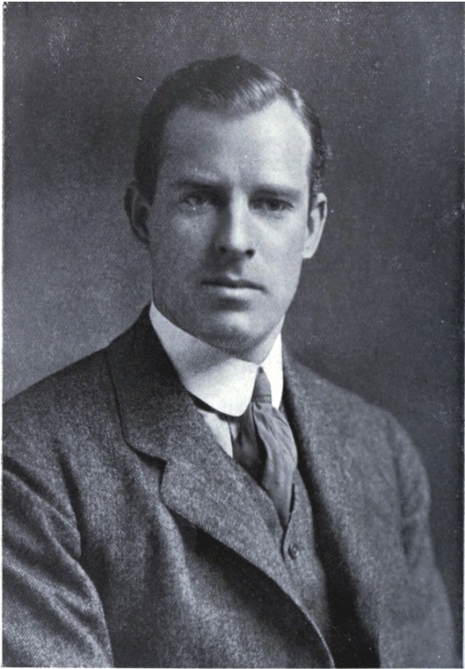
Anthony Wilding, the son of Mr F Wilding, was born in New Zealand. He came to England and was a student at Trinity College, Cambridge and was called to the Bar at the Inner Temple in 1906 and qualified as a Barrister and Solicitor of the Supreme Court of New Zealand in 1909. He was a Wimbledon Tennis Champion, winning the Doubles on 1907 and 1908, Singles and Doubles in 1910 and Singles in 1912, 1913, and 1914.
At the outbreak of World War I, Wilding joined the Royal Marines on the advice of Winston Churchill, who was then First Lord of the Admiralty. He was gazetted a second lieutenant in early October 1914. Wilding remained in the Marines for just a few days and was then attached to the Intelligence Corps due to his intimate knowledge of the continent and his skills as a motorist. At the end of October he joined the Royal Naval Armoured Car Division in the battlefields of northern France where he had thirty men, three guns and armoured cars under his command. After a week's leave in London in February 1915 he returned to France on 16 March 1915 and was posted to a new squadron made up of armoured Rolls Royce cars under the command of the Duke of Westminster. He was ranked a lieutenant. Before long the squadron was moved near the front and on 2 May Wilding received notice of his promotion to Captain.
In his last letter dated 8 May he wrote, ‘For really the first time in seven and a half months I have a job on hand which is likely to end in my gun, I, and the whole outfit being blown to hell. However if we succeed we will help our infantry no end.’
The next day, 9 May, he was killed in action at 4.45 in the afternoon during the Battle of Aubers Ridge at Neuve-Chapelle, France when a shell exploded on the roof of the dug-out he was sheltering in.
Captain Tony Wilding was buried the next day at the front but was later reinterred at the Rue-des-Berceaux Military Cemetery in Richebourg-L'Avoue, Pas-de-Calais, France. He was 31 years of age and had been dating and was about to marry Broadway star, Maxine Elliott, 15 years his senior, who lived at Hartsbourne Manor, Bushey Heath.

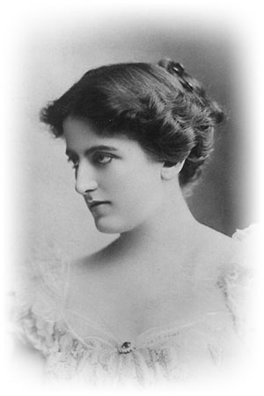
Maxine Elliott (1873-1940)

