Percy Walter Wilks
Percy Walter Wilks, born in about 1877 in Dalston, London, was the son of Ezra and Emma Wilks. His father was a collier agent and Percy was one of their six children. In 1881, just after Percy was born, the family lived at 32 Lansdowne Road in West Hackney, where they employed two servants. At the time of the 1891 census, Percy was a boarding pupil at The Leys School for Boys in Cambridge. By 1901 his family had moved to Watford and were living at ‘Ashlyns’, Clarendon Road and Percy was employed as a clerk to the coal board. By 1911 he had married and at that time he and his wife, Edith Catherine, had two children, Walter Hugh, aged 3 and Enid Louise, aged 10 months. They were living at ‘Aldbury’, Granville Road, Barnet. Percy was described in the census as a ‘coal merchant’. Between 1911 and 1918 Percy and his family moved to 13 Oxhey Road, Oxhey. In 1918 he was recorded as an Absentee Voter from this address, serving as a Second Lieutenant with the Army Service Corps.
On 10 October 1918 he was on RMS Leinster when it was torpedoed in the Irish Sea and he was drowned. He was buried at the Grangegorman Military Cemetery at Cabra, County Dublin, Ireland, plot Wes. Officers 22.
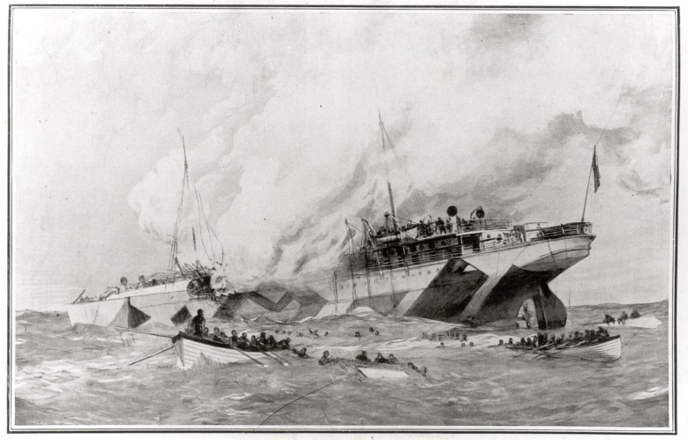
He is commemorated on the St Matthew’s Memorial, Oxhey and at Bushey & Oxhey Methodist Church, where there is a stained glass window in his memory.

