Arthur Wilson
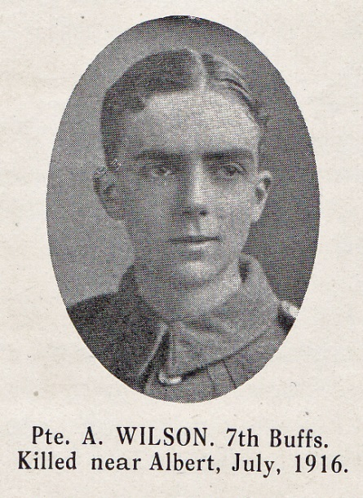
Source: The Fullerian WBGS

Arthur Wilson was born on 13 October 1892 and in 1911, at the age of 18 he was employed as a clerk at the stock exchange. He lived with his parents at ‘Cromwellhurst’, Bushey Grove Road. His father was a clerk of the council and Arthur was the third of five children. He was educated at Watford Boys’ Grammar School from 1899 to 1909.
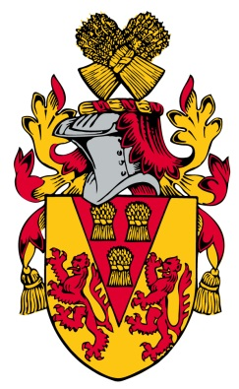
He enlisted in the East Kent Regiment (The Buffs)and was killed in action of 1 July 1916, the first day of the Somme. He is commemorated at Thiepval, the memorial to the Missing of the Somme. His name is recorded on the memorial at St Paul’s Church, Bushey. His parents later moved to 37 Cassiobury Park Road, Watford.

