John Gray Woolman
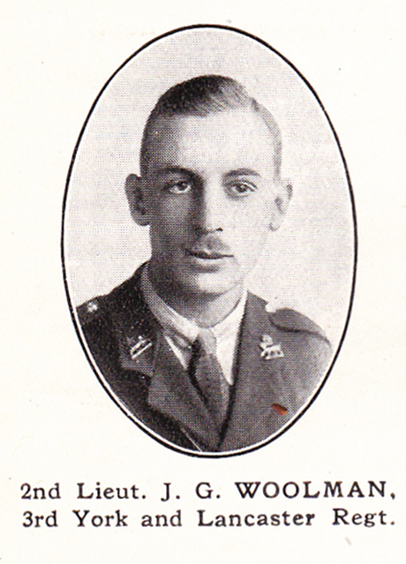
Source: The Fullerian WBGS
John Gray Woolman, born in Bushey on 7 January 1897, was the third son of John and Agnes Woolman, one of seven children. His father was a librarian and the family initially lived in Watford, before moving to ‘Westerby’, 38 Bushey Grove Road. By 1911 his father was Director Librarian and Secretary of the Public Library and School of Science and Art in Watford.
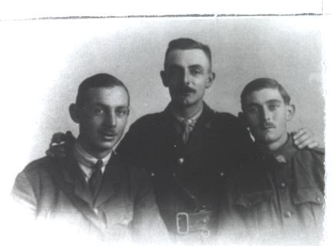

John Gray Woolman (left) with his brothers, Ebenezer and Mark
‘Second Lieutenant J C Woolman, Yorks and Lancs Regiment, son of Mr J Woolman, Watford Librarian, was killed in action on 2 November 1918. The deceased, who was 21 years of age, was leading his platoon against some enemy posts when he met his death from a rifle bullet. His captain, writing to the deceased’s parents, says, “He was in my company and was greatly beloved by both officers and men of this battalion. As a boy, he obtained a scholarship from Watford Grammar School to Christ’s Hospital, and was monitor of his house with Sidney Dawes, another Watford Grammar School boy, who recently met his death in France. In 1913 he passed the Second Division of the Civil Service and entered the Admiralty. He could not get permission to enlist until December 1916 and he joined the Inns of Court O C T in January 1917. He received his commission in September 1917. He went out to France the following April, being in the severe engagement at Kemmel Hill. He got a poisoned thumb through a scratch on barbed wire and was in the hospital at Etaples when it was bombed. He came to England and only returned on 14 September’. Watford Observer 1918
He is remembered with honour at Auberchicourt British Cemetery, grave reference IV.A. 4. and is commemorated on the Bushey Memorial and at St Paul’s Church, Bushey.

